|  |  |
| --- | --- |
| ATM  Detailed Design | |
| **Summary** | This is the Software Detailed Design Document for the *DAIMLER MMA* Project. |

|  |  |  |
| --- | --- | --- |
| **Author** | **Review** | **Approval** |
| Title: Stefan Dominte | See Project Master Document for the roles and Project Members List for the name of people | See Project Master Document for the roles and Project Members List for the name of people |
|  |  |  |
| **Distribution** | | |
| See Project Master Document for the roles and Project Members List for the name of people | See Project Master Document for the roles and Project Members List for the name of people | See Project Master Document for the roles and Project Members List for the name of people |

Table of contents

General Information 7

1.1. Revision history * 7

1.2. Purpose and Scope 7

1.3. Referenced documents 7

1.3.1. External documents 7

1.3.2. Internal Documents 7

1.3.3. Terminology and definitions 7

2. SW atomic architectural unit design 9

2.1. Overview 9

2.2. Traceability 9

3. FEATURES 15

3.1. List Management 15

3.1.1. The one shot execution list 16

3.1.2. Cyclic lists 17

3.1.3. Decade configuration 18

3.2. Enable/Disable a test 19

3.2.1. From configuration 19

3.2.2. During run time 19

3.3. Services 19

3.3.1. ATM_Init 19

3.3.2. ATM_Shutdown 21

3.3.3. ATM_runMainFunction 22

3.3.4. ATM_runGetTestResult 23

3.3.5. ATM_runGetLastCriticalAutotestId 24

3.3.6. atm_executeAutoTest 25

3.3.7. atm_isAutoTestEnabled 26

3.3.8. atm_PlayCyclicTests 26

3.3.9. atm_PlayOneShotTests 27

3.3.10. ADC_cbk_CheckAdc 28

3.3.11. BMM_cbk_CheckHallEffectSensor 29

3.3.12. Cfg_SpecificFunction_EndMain_ATM 30

3.3.13. Cfg_SpecificFunction_Init_ATM 30

3.3.14. Cfg_SpecificFunction_Shutdown_ATM 31

3.3.15. Cfg_SpecificFunction_StartMain_ATM 31

3.3.16. CIL_cbk_CheckImplausibleData_Ignition 32

3.3.17. CIL_cbk_Buckle_CheckTimeoutError 33

3.3.18. CIL_cbk_CheckImplausibleData_Buckle 34

3.3.19. CIL_cbk_CheckImplausibleData_Presafe 34

3.3.20. CIL_cbk_Presafe_CheckTimeoutError 35

3.3.21. EOL_cbk_CheckProductEndOfLifeComfort 36

3.3.22. EOL_cbk_CheckProductEndOfLifeHighForce 37

3.3.23. EOL_cbk_CheckProductEndOfLifeLowForce 38

3.3.24. PAL_cbk_CheckCommandConsistency 39

3.3.25. PAL_cbk_CheckHighSideSwRegulation 40

3.3.26. PAL_cbk_CheckHWSelfProtection 41

3.3.27. PAL_cbk_CheckMosfetHighSC 42

3.3.28. PAL_cbk_CheckMosfetLowSC 43

3.3.29. PAL_cbk_CheckMosfetOCAT 44

3.3.30. PAL_cbk_CheckMotorConnection 45

3.3.31. PAL_cbk_CheckMotorCurrent 45

3.3.32. PAL_cbk_CheckMotorDisengagement 46

3.3.33. PAL_cbk_CheckMotorPowerOrder 47

3.3.34. PAL_cbk_CheckMotorSC 48

3.3.35. PAL_cbk_CheckMotorThermalProctection 49

3.3.36. PMP_cbk_CheckPowerSupplyOV 50

3.3.37. PMP_cbk_CheckPowerSupplyOVDuringActivation 51

3.3.38. PMP_cbk_CheckPowerSupplyUV 52

3.3.39. PMP_cbk_CheckPowerSupplyUVDuringActivation 53

3.3.40. PMP_cbk_CheckTemperatureSensor 54

3.3.41. RCM_cbk_ExtWatchdogTest_Autotest 55

3.3.42. RCM_cbk_RunResetCause_Autotest 56

3.3.43. CIL_cbk_SteeringConfiguration 57

3.3.44. CIL_cbk_CheckImplausibleData_ORC 58

3.3.45. CIL_cbk_CheckImplausibleData_Powertrain_Drv 59

3.3.46. CIL_cbk_CheckTimeoutError_API 59

3.3.47. CIL_cbk_CheckTimeoutError_BelthandoverL 60

3.3.48. CIL_cbk_CheckTimeoutError_BelthandoverR 61

3.3.49. CIL_cbk_CheckTimeoutError_Ignition 62

3.3.50. CIL_cbk_CheckTimeoutError_Powertrain 62

3.3.51. EOL_cbk_CheckProductEndOfLifeMaxForce 63

3.3.52. PMP_cbk_CheckSystemUV 64

3.3.53. CIL_cbk_CheckSteeringConfiguration 65

3.3.54. PMP_cbk_CheckSystemOV 65

3.3.55. CIL_cbk_CheckImplausibleData_API 66

3.3.56. CIL_cbk_CheckImplausibleData_Powertrain_Rdy 67

3.3.57. CIL_cbk_CheckTimeoutError_Odospeedometer 68

3.3.58. CIL_cbk_CheckVariantCoding 68

3.3.59. CIL_cbk_CheckTimeoutError_BeltAdj 69

3.3.60. SBC_cbk_SPIError 70

3.4. Types 71

3.4.1. stAutoTestConfigurationType 71

3.4.2. stCyclicListEltType 71

3.4.3. stStartupEltType 71

3.5. Variables 71

3.5.1. atm_au8AtStatuses[ATM_KU8_NB_OF_AUTOTEST] 71

3.5.2. atm_u16CurrentDecade 71

3.5.3. atm_u16StartupPeriodCnt 72

3.5.4. atm_u8CurrentTask 72

3.5.5. atm_u8CyclicTestIndex 72

3.5.6. atm_u8StartupTestIndex 72

3.5.7. castATMConfig[ATM_KU8_NB_OF_AUTOTEST] 72

3.5.8. castRunningCyclicList[((uint8) 50)] 73

3.5.9. castStartupCyclicList[((uint8) 6)] 73

3.5.10. castStartupSequentialList[((uint8) 17)] 73

3.5.11. cau32InhibitingModes[((uint8) 4)] 73

3.6. Constants 74

3.6.1. ATM_AC_AutoTestManager_START_SEC_CODE 74

3.6.2. ATM_AC_AutoTestManager_START_SEC_VAR_16 74

3.6.3. ATM_AC_AutoTestManager_START_SEC_VAR_8 74

3.6.4. ATM_AC_AutoTestManager_STOP_SEC_CODE 74

3.6.5. ATM_AC_AutoTestManager_STOP_SEC_VAR_16 74

3.6.6. ATM_AC_AutoTestManager_STOP_SEC_VAR_8 74

3.6.7. U16_GET_STEP_PERIOD(index) 75

3.6.8. U8_GET_AEC_ID(index) 75

3.6.9. ATM_AC_AutoTestManager_START_SEC_CONST_UNSPECIFIED 75

3.6.10. ATM_AC_AutoTestManager_STOP_SEC_CONST_UNSPECIFIED 75

3.6.11. IN_DECADE_0 75

3.6.12. IN_DECADE_1 75

3.6.13. IN_DECADE_2 76

3.6.14. IN_DECADE_3 76

3.6.15. IN_DECADE_4 76

3.6.16. IN_DECADE_5 76

3.6.17. IN_DECADE_6 76

3.6.18. IN_DECADE_7 76

3.6.19. IN_DECADE_8 76

3.6.20. IN_DECADE_9 77

3.6.21. KU16_STEP_EVERY_10MS 77

3.6.22. KU16_STEP_EVERY_1S 77

3.6.23. KU16_STEP_EVERY_200MS 77

3.6.24. KU16_STEP_EVERY_500MS 77

3.6.25. KU16_STEP_EVERY_100MS 77

3.6.26. KU8_ATM_ONE_SHOT(step_period) 78

3.6.27. KU8_ATM_ONE_SHOT_ABORT(step_period) 78

3.6.28. KU8_ATM_ONE_SHOT_DECIDED(step_period) 78

3.6.29. KU8_ATM_ONE_SHOT_RETRY(step_period) 78

3.6.30. KU8_ATM_PERIODIC_100_MS(decade) 78

3.6.31. KU8_ATM_PERIODIC_10_MS 79

3.6.32. KU8_ATM_PERIODIC_20_MS 79

3.6.33. KU8_ATM_PERIODIC_1_S(decade) 79

3.6.34. KU8_END_OF_SUB_LIST 79

3.6.35. KU8_END_OF_THE_WHOLE_LIST 79

3.6.36. KU16_CFG_MAX_DECADE 80

3.6.37. KU16_CFG_MAX_TASK 80

3.6.38. KU8_MODES______________________INHIB 80

3.6.39. KU8_MODES________VOLTAG_INHIB 80

3.6.40. KU8_MODES_BELTFN________INHIB 80

3.6.41. KU8_MODES_BELTFN_VOLTAG_INHIB 80

3.6.42. KU8_NUMBER_OF_INHIBITING_MODES 81

3.6.43. ATM_KU8_NB_OF_STARTUP_AUTO_TESTS 81

3.6.44. KU8_NB_OF_RUNNING_CYCLIC_ELTS 81

3.6.45. KU8_NB_OF_STARTUP_CYCLIC_ELTS 81

3.6.46. KU8_AUTO_TEST_CONFIG_NO_TYPE 81

3.6.47. KU8_AUTO_TEST_CONFIG_TYPE_ONE_SHOT 81

3.6.48. KU8_AUTO_TEST_CONFIG_TYPE_ONE_SHOT_ABORT 82

3.6.49. KU8_AUTO_TEST_CONFIG_TYPE_ONE_SHOT_DECIDED 82

3.6.50. KU8_AUTO_TEST_CONFIG_TYPE_ONE_SHOT_RETRY 82

3.6.51. KU8_AUTO_TEST_CONFIG_TYPE_PERIODIC 82

4. EEPROM 82

5. Configuration 82

6. Compilation Options 83

Tables of figure:

Figure 1: Critical Autotest time stamp 16

Figure 2: Cyclic Tests Time Stamp 17

Figure 3: Types of delimiter for Autotests list 18

Figure 4: Decade configuration 18

Figure 5:ATM_Init 21

Figure 6: ATM_Shutdown 22

Figure 7: ATM_runMainFunction 23

Figure 8: ATM_runGetTestResult 24

Figure 9: ATM_runGetLastCriticalAutotestId 25

Figure 10: executeAutoTest 26

Figure 11: atm_isAutoTestEnabled 26

Figure 12: atm_PlayCyclicTests 27

Figure 13: atm_PlayOneShotTests 28

Figure 14: ADC_cbk_CheckAdc 29

Figure 15: BMM_cbk_CheckHallEffectSensor 29

Figure 16: Cfg_SpecificFunction_EndMain_ATM 30

Figure 17: Cfg_SpecificFunction_Init_ATM 31

Figure 18: Cfg_SpecificFunction_Shutdown_ATM 31

Figure 19: Cfg_SpecificFunction_StartMain_ATM 32

Figure 20: CIL_cbk_CheckImplausibleData_Ignition 33

Figure 21: CIL_cbk_Buckle_CheckTimeoutError 33

Figure 22: CIL_cbk_CheckImplausibleData_Buckle 34

Figure 23: CIL_cbk_CheckImplausibleData_Presafe 35

Figure 24: CIL_cbk_Presafe_CheckTimeoutError 36

Figure 25: EOL_cbk_CheckProductEndOfLifeComfort 37

Figure 26: EOL_cbk_CheckProductEndOfLifeHighForce 38

Figure 27:EOL_cbk_CheckProductEndOfLifeLowForce 39

Figure 28: PAL_cbk_CheckCommandConsistency 40

Figure 29: PAL_cbk_CheckHighSideSwRegulation 41

Figure 30: PAL_cbk_CheckHWSelfProtection 42

Figure 31: PAL_cbk_CheckMosfetHighSC 43

Figure 32: PAL_cbk_CheckMosfetLowSC 44

Figure 33: PAL_cbk_CheckMosfetOCAT 44

Figure 34: PAL_cbk_CheckMotorConnection 45

Figure 35: PAL_cbk_CheckMotorCurrent 46

Figure 36: PAL_cbk_CheckMotorDisengagement 47

Figure 37: PAL_cbk_CheckMotorPowerOrder 48

Figure 38: PAL_cbk_CheckMotorSC 49

Figure 39: PAL_cbk_CheckMotorThermalProctection 50

Figure 40: PMP_cbk_CheckPowerSupplyOV 51

Figure 41: PMP_cbk_CheckPowerSupplyOVDuringActivation 52

Figure 42: PMP_cbk_CheckPowerSupplyUV 53

Figure 43: PMP_cbk_CheckPowerSupplyUVDuringActivation 54

Figure 44: PMP_cbk_CheckTemperatureSensor 55

Figure 45: RCM_cbk_ExtWatchdogTest_Autotest 56

Figure 46: RCM_cbk_RunResetCause_Autotest 57

Figure 47:CIL_cbk_SteeringConfiguration 58

Figure 48:CIL_cbk_CheckImplausibleData_ORC 58

Figure 49:CIL_cbk_CheckImplausibleData_Powertrain_Drv 59

Figure 50:CIL_cbk_CheckTimeoutError_API 60

Figure 51:CIL_cbk_CheckTimeoutError_BelthandoverL 61

Figure 52:CIL_cbk_CheckTimeoutError_BelthandoverR 61

Figure 53:CIL_cbk_CheckTimeoutError_Ignition 62

Figure 54:CIL_cbk_CheckTimeoutError_Powertrain 63

Figure 55: EOL_cbk_CheckProductEndOfLifeMaxForce 64

Figure 56:PMP_cbk_CheckSystemUV 64

Figure 57: CIL_cbk_CheckSteeringConfiguration 65

Figure 58:PMP_cbk_CheckSystemOV 66

Figure 59 CIL_cbk_CheckImplausibleData_API 67

Figure 60 CIL_cbk_CheckImplausibleData_Powertrain_Rdy 67

Figure 61 CIL_cbk_CheckTimeoutError_Odospeedometer 68

Figure 62 CIL_cbk_CheckVariantCoding 69

Figure 63 CIL_cbk_CheckTimeoutError_BeltAdj 70

Figure 64 SBC_cbk_SPIError 70

# General Information

## Revision history *

|  |  |  |  |
| --- | --- | --- | --- |
| **Revision** | **Date** | **Author(s)** | **Description/comment** |
| 1.1.1.1.2.1 | 09.09.2022 | Stefan Dominte | Initial revision |
| 1.1.1.1.2.2 | 15.11.2022 | Mirela Obada | Update for 4.0 |
| 1.1.1.1.2.3 | 15.11.2022 | Mirela Obada | Update names for functions and variables |
| 1.1.1.1.2.4 | 22.11.22 | Mirela Obada | Update after review |
| 1.1.1.1.2.5 | 08.02.2023 | Madalina Serban | Update functions and traceability |
| 1.1.1.1.2.6 | 14.02.2023 | Madalina Serban | Fixes after review |
| 1.1.1.1.2.7 | 15.02.2023 | Madalina Serban | Fixes after review |
| 1.1.1.1.2.8 | 15.02.2023 | Madalina Serban | Fixes after review |
| 1.1.1.1.2.9 | 08.05.2023 | Mirela Obada | Update for 6.0 |
| 1.1.1.1.2.10 | 08.05.2023 | Mirela Obada | Update traceability |
| 1.1.1.1.2.11 | 10.05.2023 | Mirela Obada | Update after review |
| 1.1.1.1.2.12 | 10.05.2023 | Mirela Obada | Update after review |
| 1.1.1.1.2.13 | 24.08.2023 | Mirela Obada | Update for R07.0 |
| 1.1.1.1.2.14 | 01.09.2023 | Mirela Obada | Fix after review |
| 1.1.1.1.2.15 | 06.10.2023 | Mirela Obada | Update inhibition masks |
| 1.1.1.1.2.16 | 18.01.2024 | Mirela Obada | Update inhibit modes for 8.1 |
| 1.1.1.1.2.17 | 03.04.2024 | Mirela Obada | Update whit SPI autotest R09.0 P91 |

*\* Template history is found in the CM tool used for templates*

## Purpose and Scope

The purpose of this document is to provide an overview of the ATM operation principle, and to present the implementation choices in terms of module and function splitting.

## Referenced documents

### External documents

|  |  |  |
| --- | --- | --- |
| **Id** | **Title** | **Reference** |
|  |  |  |
|  |  |  |
|  |  |  |

### Internal Documents

|  |  |  |
| --- | --- | --- |
| **Id** | **Title** | **Reference** |
|  | DAIMLER_MMA_SWarchitectureDesignInterfaceDescription.docx |  |
|  | ATM - Design Interface Description.docx |  |
|  | SBE_4G_NVP_layout.xls |  |
|  |  |  |

### Terminology and definitions

|  |  |
| --- | --- |
| **Terminology** | **Meaning** |
| AAU | Atomic architectural unit |
| AEC | Autoliv Error Code |
| ATM | Auto-Tests Manager |
| SCH | Scheduler |
| ERH | Error Handler |
| MMG | Mode ManaGement |
| SW | Software |

# SW atomic architectural unit design

## Overview

The aim of the “ATM” (Auto-Tests Manager) component is to schedule auto-tests and manage the reported failures. ATM handles periodic or one shot test.

The ATM provides 5 test lists and a unique one for the startup auto-test. ATM main function is called by the SCH every 2ms.

The configurability of the ATM includes:

* Test types : cyclic or one shot
* List, period and slot/decade
* MMG inhibiting modes
* Autoliv Error Code (provided by ERH)
* Callback function
* Enable/Disable switch

## Traceability

|  |  |  |  |
| --- | --- | --- | --- |
| Requirements | Criteria | Linked Runnable | Source |
| DSG_ATM_0001 | The local variable castStartupSequentialList will hold the list of the auto-tests which will be executed at start-up:   * RCM_Autotest_RunResetCause * EOL_Autotest_CheckProductEndOfLifeLowForce * EOL_Autotest_CheckProductEndOfLifeHighForce * EOL_Autotest_CheckProductEndOfLifeComfort * PAL_Autotest_CheckHighSideSwRegulation * PAL_Autotest_CheckCommandConsistency * PAL_Autotest_CheckMosfetHighSC * PAL_Autotest_CheckMosfetLowSC * PAL_Autotest_CheckMotorConnection * PAL_Autotest_CheckHWSelfProtection * PAL_Autotest_CheckMosfetOCAT * EOL_Autotest_CheckProductEndOfLifeMaxForce * ADC_cbk_CheckAdc | ATM_ runMainFunction() | ARCH_SW_ATM_0106; ARCH_SW_ATM_0107; ARCH_SW_ATM_0108; ARCH_SW_ATM_0109; ARCH_SW_ATM_0114; ARCH_SW_ATM_0115; ARCH_SW_ATM_0116; ARCH_SW_ATM_0117; ARCH_SW_ATM_0118; ARCH_SW_ATM_0119; ARCH_SW_ATM_0120; ARCH_SW_ATM_0110; |
| DSG_ATM_0002 | The local variable castRunningCyclicList will hold the list of the auto-tests which will be executed cyclic:   * PMP_Autotest_CheckPowerSupplyUVDuringActivation * PMP_Autotest_CheckPowerSupplyOVDuringActivation * PAL_Autotest_CheckCommandConsistency * PAL_CheckMosfetHighSC * PAL_CheckMosfetLowSC * PAL_CheckMotorConnection * PAL_CheckHWSelfProtection * PAL_CheckMotorDisengagement * BMM_CheckHallEffectSensor * PAL_CheckMotorCurrent * EOL_CheckProductEndOfLifeLowForce * PMP_CheckPowerSupplyUV * PMP_CheckPowerSupplyOV * PAL_CheckMotorPowerOrder * PMP_CheckTemperatureSensor * EOL_Autotest_CheckProductEndOfLifeHighForce * EOL_Autotest_CheckProductEndOfLifeComfort * PAL_CheckMotorSC * PAL_CheckMotorThermalProctection * CIL_Autotest_Presafe_CheckTimeoutError * CIL_Autotest_Presafe_CheckTimeoutError * CIL_Autotest_CheckImplausibleData_Presafe * CIL_Autotest_CheckImplausibleData_Ignition * CIL_Autotest_CheckImplausibleData_Buckle * CIL_Autotest_CheckTimeoutError_Powertrain * CIL_Autotest_CheckTimeoutError_Ignition * CIL_Autotest_CheckImplausibleData_Powertrain * CIL_Autotest_CheckImplausibleData_ORC * CIL_Autotest_CheckTimeoutError_ Belthandover_L * CIL_Autotest_CheckTimeoutError_ Belthandover_R * CIL_Autotest_CheckTimeoutError_API * EOL_cbk_CheckProductEndOfLifeMaxForce * CIL_cbk_SteeringConfiguration * ADC_cbk_CheckAdc * PMP_Autotest_CheckSystemUV * PMP_Autotest_CheckSystemOV * CIL_Autotest_CheckTimeoutError_API * CIL_Autotest_CheckImplausibleData_Powertrain_Drv * CIL_Autotest_CheckTimeout_Odospeedometer * CIL_Autotest_CheckImplausibledataAPI * CIL_Autotest_CheckVariantCoding * CIL_Autotest_CheckTimeoutError_BeltAdj * SBC_ServiceAutotest_GetTestResult | ATM_ runMainFunction() | ARCH_SW_ATM_0202; ARCH_SW_ATM_0203; ARCH_SW_ATM_0205; ARCH_SW_ATM_0206; ARCH_SW_ATM_0207; ARCH_SW_ATM_0208; ARCH_SW_ATM_0209; ARCH_SW_ATM_0210; ARCH_SW_ATM_0211; ARCH_SW_ATM_0212; ARCH_SW_ATM_0213; ARCH_SW_ATM_0214; ARCH_SW_ATM_0215; ARCH_SW_ATM_0216; ARCH_SW_ATM_0217; ARCH_SW_ATM_0218; ARCH_SW_ATM_0219; ARCH_SW_ATM_0220; ARCH_SW_ATM_0221; ARCH_SW_ATM_0222; ARCH_SW_ATM_0223; ARCH_SW_ATM_0224; ARCH_SW_ATM_0225; ARCH_SW_ATM_0226;ARCH_SW_ATM_0227;ARCH_SW_ATM_0228; ARCH_SW_ATM_0229; ARCH_SW_ATM_0230; ARCH_SW_ATM_0231; ARCH_SW_ATM_0232; ARCH_SW_ATM_0233; ARCH_SW_ATM_0234; ARCH_SW_ATM_0235; ARCH_SW_ATM_0236; ARCH_SW_ATM_0237; ARCH_SW_ATM_0238; ARCH_SW_ATM_0239; ARCH_SW_ATM_0150; ARCH_SW_ATM_0151; ARCH_SW_ATM_0152; ARCH_SW_ATM_0153; |
| DSG_ATM_0047 | The local variable castStartupCyclicList will hold the list of the auto-tests which will be executed cyclic with one shot autotests:   * PMP_Autotest_CheckSystemUV * PMP_Autotest_CheckSystemOV PMP_cbk_CheckPowerSupplyOV * PMP_cbk_CheckPowerSupplyUV |  | ARCH_SW_ATM_0235; ARCH_SW_ATM_0236; ARCH_SW_ATM_0214; ARCH_SW_ATM_0215; |
| DSG_ATM_0003 | The local variable **au8AtStatuses** will be initialized with the value KU8_ATM_TEST_NOT_DECIDED. | ATM_Init() | ARCH_SW_ATM_0001; |
| DSG_ATM_0004 | The local variable **au8AtStatuses** will hold the autotests status and will be the return value in the ATM_runGetTestResult runnable. | ATM_runGetTestResult() | ARCH_SW_ATM_0002; |
| DSG_ATM_0005 | The local variable **u8StartupTestIndex** will hold the index of the Start Up Autotest executed. When the variable will be higher than ATM_KU8_NB_OF_STARTUP_AUTO_TESTS cyclic autotests will be executed. | ATM_ runMainFunction() | ARCH_SW_ATM_0004; |
| DSG_ATM_0006 | ATM_runMainFunction will be called cyclic at every 2ms. | ATM_ runMainFunction() | ARCH_SW_ATM_0003; |
| DSG_ATM_0007 | The local function executeAutoTest will set the status of an autotest to KU8_ATM_TEST_NOT_DECIDED if an autotest cannot be executed. | ATM_ runMainFunction() | ARCH_SW_ATM_0260; |
| DSG_ATM_0008 | The local function executeAutoTest will call the MMG_runCheckModeStatus in order to read the current system context for a specific autotests. | ATM_ runMainFunction() | ARCH_SW_ATM_0021; |
| DSG_ATM_0009 | The local function executeAutoTest will inhibit the **ATM_KU8_ID_TEST_HIGH_SIDE_SWITCH** autotest if KU8_MODES________VOLTAG_INHIB is read from MMG_runCheckModeStatus function. | ATM_ runMainFunction() | ARCH_SW_ATM_0030; |
| DSG_ATM_0010 | The local function executeAutoTest will inhibit the **ATM_KU8_ID_TEST_DRIVER_COMMAND** autotest if KU8_MODES_______________INHIB is read from MMG_runCheckModeStatus function. | ATM_ runMainFunction() | ARCH_SW_ATM_0031; |
| DSG_ATM_0011 | The local function executeAutoTest will inhibit the **ATM_KU8_ID_TEST_MOSFET_HIGH_SHORT_CIRCUIT** autotest if KU8_MODES_BELTFN_VOLTAG_INHIB is read from MMG_runCheckModeStatus function. | ATM_ runMainFunction() | ARCH_SW_ATM_0032; |
| DSG_ATM_0012 | The local function executeAutoTest will inhibit the **ATM_KU8_ID_TEST_MOSFET_LOW_SHORT_CIRCUIT** autotest if KU8_MODES_BELTFN_VOLTAG_INHIB is read from MMG_runCheckModeStatus function. | ATM_ runMainFunction() | ARCH_SW_ATM_0033; |
| DSG_ATM_0013 | The local function executeAutoTest will inhibit the **ATM_KU8_ID_TEST_MOTOR_DISCONNECTION** autotest if KU8_MODES_BELTFN_VOLTAG_INHIB is read from MMG_runCheckModeStatus function. | ATM_ runMainFunction() | ARCH_SW_ATM_0034; |
| DSG_ATM_0014 | The local function executeAutoTest will inhibit the **ATM_KU8_ID_TEST_DRIVER_SELF_PROTECTION** autotest if **KU8_MODES**_______________**INHIB** is read from MMG_runCheckModeStatus function. | ATM_ runMainFunction() | ARCH_SW_ATM_0035; |
| DSG_ATM_0015 | The local function executeAutoTest will inhibit the **ATM_KU8_ID_TEST_MOSFET_OPEN_CIRCUIT** autotest if **KU8_MODES_BELTFN_VOLTAG_INHIB** is read from MMG_runCheckModeStatus function. | ATM_ runMainFunction() | ARCH_SW_ATM_0036; |
| DSG_ATM_0016 | The local function executeAutoTest will inhibit the **ATM_KU8_ID_TEST_HALL_EFFECT_SENSORS** autotest if **KU8_MODES________VOLTAG_INHIB** is read from MMG_runCheckModeStatus function. | ATM_ runMainFunction() | ARCH_SW_ATM_0037; |
| DSG_ATM_0017 | The local function executeAutoTest will inhibit the **ATM_KU8_ID_TEST_MOTOR_CURRENT** autotest if **KU8_MODES________VOLTAG_INHIB** is read from MMG_runCheckModeStatus function. | ATM_ runMainFunction() | ARCH_SW_ATM_0038; |
| DSG_ATM_0018 | The local function executeAutoTest will inhibit the **ATM_KU8_ID_TEST_MOTOR_BLOCKED** autotest if **KU8_MODES________VOLTAG_INHIB** is read from MMG_runCheckModeStatus function. | ATM_ runMainFunction() | ARCH_SW_ATM_0039; |
| DSG_ATM_0019 | The local function executeAutoTest will inhibit the **ATM_KU8_ID_TEST_MOTOR_TEMPERATURE** autotest if **KU8_MODES________VOLTAG_INHIB** is read from MMG_runCheckModeStatus function. | ATM_ runMainFunction() | ARCH_SW_ATM_0040; |
| DSG_ATM_0020 | The local function executeAutoTest will inhibit the **ATM_KU8_ID_TEST_MOTOR_SHORT_CIRCUIT** autotest if **KU8_MODES________________INHIB** is read from MMG_runCheckModeStatus function. | ATM_ runMainFunction() | ARCH_SW_ATM_0041; |
| DSG_ATM_0021 | The local function executeAutoTest will inhibit the **ATM_KU8_ID_TEST_SENSOR_TEMPERATURE** autotest if **KU8_MODES________________INHIB** is read from MMG_runCheckModeStatus function. | ATM_ runMainFunction() | ARCH_SW_ATM_0042; |
| DSG_ATM_0022 | The local function executeAutoTest will inhibit the **ATM_KU8_ID_TEST_PWM_ORDER** autotest if **KU8_MODES________VOLTAG_INHIB** is read from MMG_runCheckModeStatus function. | ATM_ runMainFunction() | ARCH_SW_ATM_0043; |
| DSG_ATM_0023 | The local function executeAutoTest will inhibit the **ATM_KU8_ID_TEST_UNDER_VOLTAGE_POWER** autotest if KU8_MODES________________INHIB is read from MMG_runCheckModeStatus function. | ATM_ runMainFunction() | ARCH_SW_ATM_0044; |
| DSG_ATM_0024 | The local function executeAutoTest will inhibit the **ATM_KU8_ID_TEST_OVER_VOLTAGE_POWER** autotest if KU8_MODES________________INHIB is read from MMG_runCheckModeStatus function. | ATM_ runMainFunction() | ARCH_SW_ATM_0045; |
| DSG_ATM_0025 | The local function executeAutoTest will inhibit the **ATM_KU8_ID_TEST_UNDER_VOLTAGE_TENSIONING_POWER** autotest if KU8_MODES________________INHIB is read from MMG_runCheckModeStatus function. | ATM_ runMainFunction() | ARCH_SW_ATM_0046; |
| DSG_ATM_0026 | The local function executeAutoTest will inhibit the **ATM_KU8_ID_TEST_OVER_VOLTAGE_TENSIONING_POWER** autotest if KU8_MODES________________INHIB is read from MMG_runCheckModeStatus function. | ATM_ runMainFunction() | ARCH_SW_ATM_0047; |
| DSG_ATM_0027 | The local function executeAutoTest will inhibit the **ATM_KU8_ID_EXT_WDG_OUT_OF_ORDER** autotest if KU8_MODES________________INHIB is read from MMG_runCheckModeStatus function. | ATM_ runMainFunction() | ARCH_SW_ATM_0048; |
| DSG_ATM_0028 | The local function executeAutoTest will inhibit the **ATM_KU8_ID_RESET_CAUSE** autotest if KU8_MODES________________INHIB is read from MMG_runCheckModeStatus function. | ATM_ runMainFunction() | ARCH_SW_ATM_0049; |
| DSG_ATM_0029 | The local function executeAutoTest will inhibit the **ATM_KU8_ID_END_OF_LIFE_LOW_FORCE** autotest if KU8_MODES______________________INHIB is read from MMG_runCheckModeStatus function. | ATM_ runMainFunction() | ARCH_SW_ATM_0050; |
| DSG_ATM_0030 | The local function executeAutoTest will inhibit the **ATM_KU8_ID_END_OF_LIFE_HIGH_FORCE** autotest if KU8_MODES______________________INHIB is read from MMG_runCheckModeStatus function. | ATM_ runMainFunction() | ARCH_SW_ATM_0051; |
| DSG_ATM_0031 | The local function executeAutoTest will inhibit the **ATM_KU8_ID_END_OF_LIFE_COMFORT** autotest if KU8_MODES______________________INHIB is read from MMG_runCheckModeStatus function. | ATM_ runMainFunction() | ARCH_SW_ATM_0052; |
| DSG_ATM_0032 | The local function executeAutoTest will inhibit the **ATM_KU8_ID_TIMEOUT_PRESAFE** autotest is inhibited by KU8_MODES______________________INHIB is read from MMG_runCheckModeStatus function. | ATM_ runMainFunction() | ARCH_SW_ATM_0053; |
| DSG_ATM_0033 | The local function executeAutoTest will inhibit the **ATM_KU8_ID_TIMEOUT_BUCKLE autotest is inhibited by KU8_MODES______________________INHIB and KU8_MODES_ENABLE_____IGNITION are** read from MMG_runCheckModeStatus function. | ATM_ runMainFunction() | ARCH_SW_ATM_0054; |
| DSG_ATM_0034 | The local function executeAutoTest will inhibit the **ATM_KU8_ID_IMPLAUSIBLE_DATA_PRESAFE** autotest is inhibited by KU8_MODES______________________INHIB and KU8_MODES_ENABLE_____IGNITION are read from MMG_runCheckModeStatus function. | ATM_ runMainFunction() | ARCH_SW_ATM_0055; |
| DSG_ATM_0035 | The local function executeAutoTest will inhibit the **ATM_KU8_ID_IMPLAUSIBLE_DATA_IGNITION** autotest if KU8_MODES______________________INHIB and KU8_MODES_ENABLE_____IGNITION are read from MMG_runCheckModeStatus function. | ATM_ runMainFunction() | ARCH_SW_ATM_0056; |
| DSG_ATM_0036 | The local function executeAutoTest will inhibit the **ATM_KU8_ID_IMPLAUSIBLE_DATA_BUCKLE** autotest if KU8_MODES______________________INHIB **and KU8_MODES_ENABLE_____IGNITION are** read from MMG_runCheckModeStatus function. | ATM_ runMainFunction() | ARCH_SW_ATM_0057; |
| DSG_ATM_0037 | The local function executeAutoTest will inhibit the **ATM_KU8_ID_END_OF_LIFE_MAX_FORCE** autotest if KU8_MODES______________________INHIB is read from MMG_runCheckModeStatus function. | ATM_ runMainFunction() | ARCH_SW_ATM_0058; |
| DSG_ATM_0038 | The local function executeAutoTest will inhibit the  **ATM_KU8_ID_ TIMEOUT_IGNITION** autotest if KU8_MODES______________________INHIB is read from MMG_runCheckModeStatus function. | ATM_ runMainFunction() | ARCH_SW_ATM_0059; |
| DSG_ATM_0039 | The local function executeAutoTest will inhibit the **ATM_KU8_ID_ TIMEOUT_POWERTRAIN** autotest if KU8_MODES______________________INHIB is read from MMG_runCheckModeStatus function. | ATM_ runMainFunction() | ARCH_SW_ATM_0060; |
| DSG_ATM_0040 | The local function executeAutoTest will inhibit the **ATM_KU8_ID_ IMPLAUSIBLE_DATA _POWERTRAIN_RDY** autotest if by KU8_MODES______________________INHIB is read from MMG_runCheckModeStatus function. | ATM_runMainFunction () | ARCH_SW_ATM_0061; |
| DSG_ATM_0041 | The local function executeAutoTest will inhibit the **ATM_KU8_ID_ IMPLAUSIBLE_DATA _ORC** autotest if KU8_MODES______________________INHIB and KU8_MODES_ENABLE_____IGNITION are read from MMG_runCheckModeStatus function. | ATM_runMainFunction () | ARCH_SW_ATM_0062; |
| DSG_ATM_0042 | The local function executeAutoTest will inhibit the **ATM_KU8_ID_ TIMEOUT _BELT_HAND_OVER_LEFT** autotest if KU8_MODES______________________INHIB and KU8_MODES_ENABLE_CodingRBTMFL are read from MMG_runCheckModeStatus function. | ATM_runMainFunction () | ARCH_SW_ATM_0063; |
| DSG_ATM_0043 | The local function executeAutoTest will inhibit the **ATM_KU8_ID_ TIMEOUT _BELT_HAND_OVER_RIGHT** autotest if KU8_MODES______________________INHIB and KU8_MODES_ENABLE_CodingRBTMFR are read from MMG_runCheckModeStatus function. | ATM_runMainFunction () | ARCH_SW_ATM_0064; |
| DSG_ATM_0044 | The local function executeAutoTest will inhibit the **ATM_KU8_ID_TIMEOUT _API_INTERFACE** autotest if KU8_MODES______________________INHIB is read from MMG_runCheckModeStatus function. | ATM_runMainFunction () | ARCH_SW_ATM_0065; |
| DSG_ATM_0045 | The local function executeAutoTest will inhibit the **ATM_KU8_ID_OVERVOLTAGE_SYSTEM** autotest if KU8_MODES______________________INHIB is read from MMG_runCheckModeStatus function. | ATM_runMainFunction () | ARCH_SW_ATM_0066; |
| DSG_ATM_0046 | The local function executeAutoTest will inhibit the **ATM_KU8_ID_ UNDERVOLTAGE_SYSTEM** autotest if KU8_MODES______________________INHIB is read from MMG_runCheckModeStatus function. | ATM_runMainFunction () | ARCH_SW_ATM_0067; |
| DSG_ATM_0047 | The local function executeAutoTest will inhibit the **ATM_KU8_ID_TIMEOUT_API** autotest if KU8_MODES______________________INHIB and KU8_MODES_ENABLE_____IGNITION are read from MMG_runCheckModeStatus function. | ATM_runMainFunction () | ARCH_SW_ATM_0068; |
| DSG_ATM_0048 | The local function executeAutoTest will inhibit the **ATM_KU8_ID_IMPLAUSIBLE_DATA_POWERTRAIN_DRV** autotest if KU8_MODES______________________INHIB and KU8_MODES_ENABLE_____IGNITION and  KU8_MODES_ENABLE__________API are read from MMG_runCheckModeStatus function. | ATM_runMainFunction () | ARCH_SW_ATM_0069; |
| DSG_ATM_0049 | The local function executeAutoTest will inhibit the **ATM_KU8_ID_TIMEOUT_ODOSPEEDOMETER** autotest if KU8_MODES______________________INHIB is read from MMG_runCheckModeStatus function. | ATM_runMainFunction () | ARCH_SW_ATM_0070; |
| DSG_ATM_0050 | The local function executeAutoTest will inhibit the **ATM_KU8_ID_IMPLAUSIBLE_DATA_API** autotest if KU8_MODES______________________INHIB and KU8_MODES_ENABLE_____IGNITION and KU8_MODES_ENABLE__________API are read from MMG_runCheckModeStatus function. | ATM_runMainFunction () | ARCH_SW_ATM_0071; |
| DSG_ATM_0051 | The local function executeAutoTest will inhibit the **ATM_KU8_ID_VARIANT_CODING** autotest if KU8_MODES______________________INHIB is read from MMG_runCheckModeStatus function. | ATM_runMainFunction () | ARCH_SW_ATM_0072; |
| DSG_ATM_0052 | The local function shall check if an autotest is enabled according to NVP configuration | ATM_runMainFunction () |  |
| DSG_ATM_0053 | The local function executeAutoTest will inhibit the **ATM_KU8_ID_TIMEOUT_BELT_ADJ** autotest if KU8_MODES______________________INHIB is read from MMG_runCheckModeStatus function. | ATM_runMainFunction () | ARCH_SW_ATM_0073; |
| DSG_ATM_0054 | The local function executeAutoTest will inhibit the **ATM_KU8_ID_SPI_ERROR** autotest if KU8_MODES______________________INHIB is read from MMG_runCheckModeStatus function. | ATM_runMainFunction () | ARCH_SW_ATM_0074; |

# FEATURES

The purpose of this chapter is to only describe the internal implementation of the component.

For the description of the external implementation, please refer to [Doc1] (to get the list of services, types, variables and constants exported by this unit).

Actually, the description of the internal implementation is not necessary for this SW unit since its complexity is extremely low. Therefore, the current chapter shall not be treated. Then, refer to C-code implementation directly.

## List Management

ATM module implements two different behavior: “one shot” and “cyclic” executions.

During the startup phase, “critical” auto-tests are executed once sequentially (“one shot” execution). If one of them fails, the whole startup sequence is frozen and the RUN phase is not reachable. However, when all startup auto-test are passed, the RUN state is entered.

The “cyclic” execution is performed during both startup and run phases. Each phase uses its own set of test scheduling data. This cyclic execution design allow to better share the CPU load between 5 execution points by 10ms windows.

### The one shot execution list

This list contains all auto-tests that need to be executed before entering the run phase. Only one test is executed by function call. The function is called every 2ms.

The startup list is divided in two kinds of auto tests:

* First, all critical auto tests are executed.
* Then, the startup auto tests which are not critical are executed.

#### Critical auto tests

The sequence defined by the “one shot” list contains CRITICAL auto tests: they are the auto tests configured as ONE SHORT ABORT or ONE SHOT RETRY.

The test order is important because the next test is called only if the previous one was passed. They are executed sequentially. When a test fails during this sequence, two strategies can be applied:

* The test is configured as a ONE SHORT ABORT auto-test: if its status is NOK, the test is never played again and the whole sequence is stopped.
* The test is configured as a ONE SHORT RETRY auto-test: since its status is still NOK, the test is replayed again on the next task occurrence. Some of these tests are designed to be stopped until a maximum number of tries, but this mechanism is designed inside the algorithm of the tests.

Sometimes, a test needs more than one call to be fully passed. In this case, all steps are scheduled on their correct period derived from the 2ms cyclic call. When the last step is executed, the state machine moves to the next test.

A brief example of a startup list containing 3 tests is presented below:

* Test 0 and 2 are one shot test
* Test 1 is composed of 2 steps separated by 10ms.

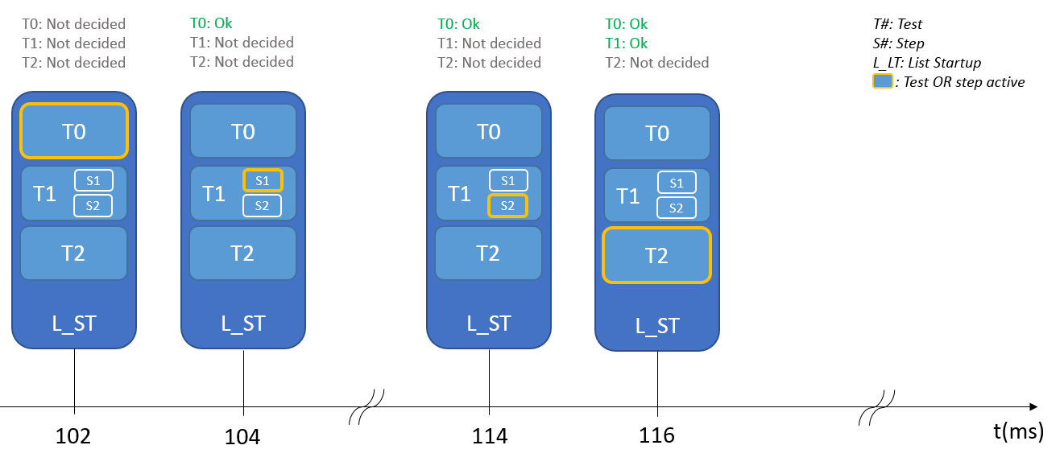

Figure : Critical Autotest time stamp

#### Not critical auto tests

The sequence defined by the “one shot” list contains also not critical auto tests.

These startup auto tests are configured as ONE SHOT.

Whatever their result is, the startup sequence goes to the next test without stopping. They are not blocking.

### Cyclic lists

Two cyclic lists coexist, to be played respectively during the “one shot” sequence, and after the “one shot” sequence completion in the case where all critical auto tests result could be “passed”.

First list is necessary to identify a fault explaining why a critical “one shot” test has failed (eg. Low voltage being monitored as cyclic test in parallel with critical autotests). The second list includes also tests that require the critical auto tests to be passed first.

Each periodic list is divided into five sub-lists to cover 10ms and more test period. Execution order is fixed and cannot be changed.

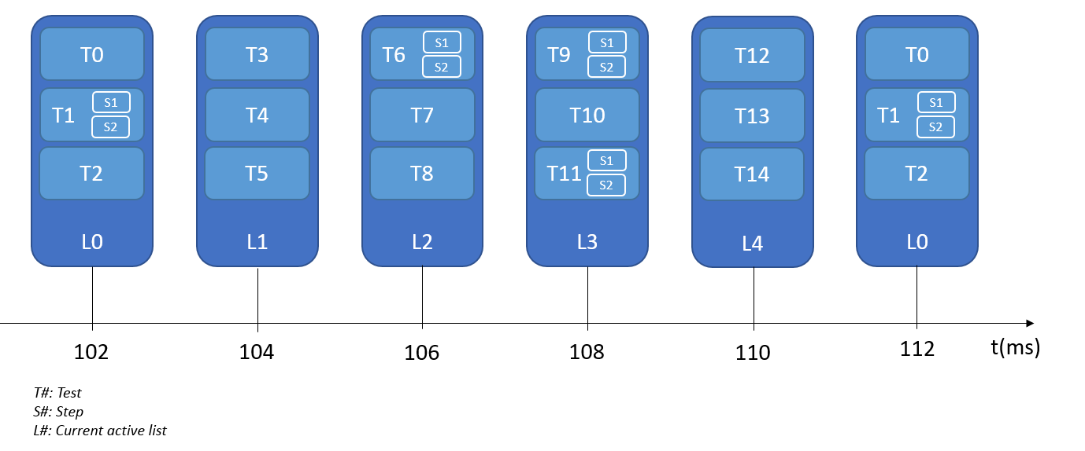

Figure : Cyclic Tests Time Stamp

These list configurations are stored respectively in *castStartupCyclicList* and *castRunningCyclicList* located in ATM_cfg.c. These arrays are splitted into five sub-lists separated by a delimiter. They are passed as argument to the atm_PlayCyclicTests function. Thanks to the sub-list separator, atm_PlayCyclicTests only loops through one table and do not have to switch between five.

Two types of delimiter are used:

* KU8_END_OF_SUB_LIST is used between lists. It has an offset of 1 indication the ATM mainFunction to continue with its current indexes.
* KU8_END_OF_THE_WHOLE_LIST terminate the list. It has an offset of 0 indicating the ATM mainFunction to loop back to the first list and reset all its indexes.

Tests shall be added between these delimiters like in the diagram presented below:

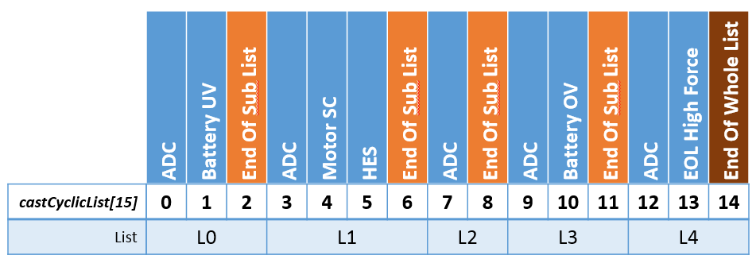

Figure : Types of delimiter for Autotests list

As the delimiters cannot be removed, total array size shall be increased by 5:

### Decade configuration

Using five lists gave us the opportunity to control the CPU load during the run phase. To achieve a better accuracy a decade parameter is added in the test configuration. It does not affect the test execution or period provided by TF-H. In fact it delays the first test execution and keep it as the base time to count the period. We can identify this parameter as an offset. We call it “Decade” because a list is activated every 10ms. If a test has this parameter set to 1, its execution will be delayed 10ms after the first activation of its list. Here is an example:

We will only use the first list with 3 tests:

* T0 – Period 100ms no decade
* T1 – Period 100ms decade 1
* T2 – Period 100ms decade 2

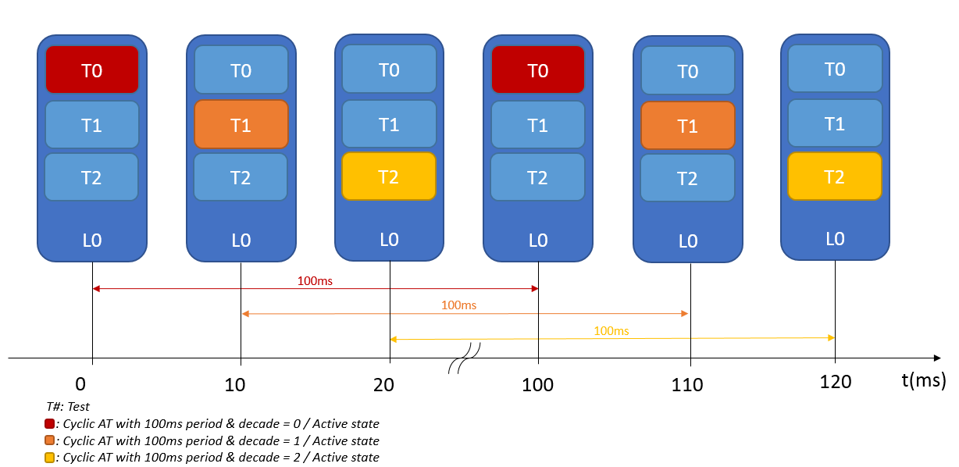

Figure : Decade configuration

The decade counter U16CurrentDecade is increased by 1 at the end of the whole list. To detect when a test shall be played its offset needs to be equal to the u16CurrentDecade counter modulo the test period:

**If** (TestOffset = (u16CurrentDecade % TestPeriod))

{

Execute test

}

**Else** {Go to next one}

## Enable/Disable a test

### From configuration

Sometimes during certain integration test campaign it is necessary to disable a test which will qualify a fault before the one you want to check. To do this, a NVP block is used: *NVP_au8AutoTestsActivation.*

A test is enabled if its state = 0xAA

A test is disabled if its state = 0x55

The correspondence between the table index and the test ID can be found in the file ATM_cfg_public.h.

### During run time

During run time, it happens that all conditions are not fulfilled to execute a test. A wrong condition could be one of these:

* Battery not stable
* Car cranking situation
* Motor activation
* Etc.

These conditions are provided as MMG mode. We link them to a test and if one of them is active the test is not executed. One auto-test can be assigned to one or more modes. You only need to contact them with a logical OR like the example below:

**#define** KU32_INHIBITING_MODES_FOR_MOSFET_HIGH_SHORT_CIRCUIT \

(MMG_KU32_MASK_CRANKING | MMG_KU32_MASK_POWER_VOLTAGE_UNSTABLE | MMG_KU32_MASK_BELTFUNCTIONS)

Here the test will be inhibited if the cranking situation is on OR if the battery is unstable OR if a tensioning cycle is played. The whole configuration can be found in ATM_cfg_private.h

## Services

### ATM_Init

|  |  |  |
| --- | --- | --- |
| Object | | |
| Service used to initialize the ATM component | | |
| **Prototype** | | |
| **void** **ATM_Init(void)** | | |
| **Input parameters** | | |
| Name | Type | Description |
| NA | NA | NA |
| **Output parameters** | | |
| Name | Type | Description |
| NA | NA | NA |
| **Return value** | | |
| Type | Description | |
| NA | void | |
| **Dynamic aspect** | | |
| Who(callers) | Description | |
| MCU | Called during ECU initialization sequence | |
| **Static aspect** | | |
| Initialize all internal variables. Auto-tests status set to NOT_DECIDED | | |
| **Constrains** | | |
| NA | | |

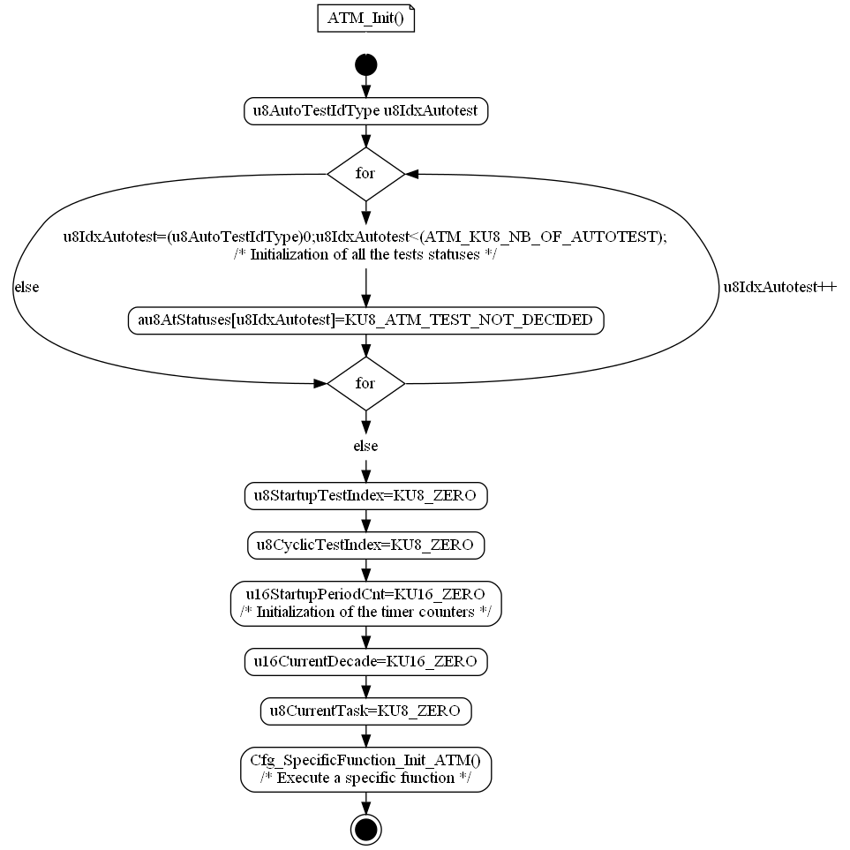

Figure :ATM_Init

### ATM_Shutdown

|  |  |  |
| --- | --- | --- |
| Object | | |
| This service is not used in the current PP4G context | | |
| **Prototype** | | |
| **void** **ATM_Shutdown (void)** | | |
| **Input parameters** | | |
| Name | Type | Description |
| NA | NA | NA |
| **Output parameters** | | |
| Name | Type | Description |
| NA | NA | NA |
| **Return value** | | |
| Type | Description | |
| NA | void | |
| **Dynamic aspect** | | |
| Who(callers) | Description | |
| NA | NA | |
| **Static aspect** | | |
| NA | | |
| **Constrains** | | |
| NA | | |

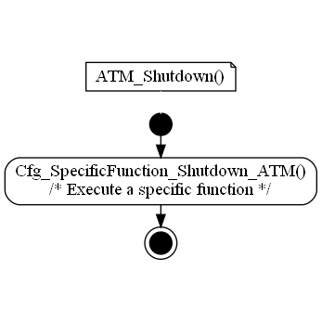

Figure : ATM_Shutdown

### ATM_runMainFunction

|  |  |  |
| --- | --- | --- |
| Object | | |
| This service is in charge of:  Scheduling all auto-tests during the startup phase and in running mode. | | |
| **Prototype** | | |
| **void** **ATM_runMainFunction (void)** | | |
| **Input parameters** | | |
| Name | Type | Description |
| NA | NA | NA |
| **Output parameters** | | |
| Name | Type | Description |
| NA | NA | NA |
| **Return value** | | |
| Type | Description | |
| NA | void | |
| **Dynamic aspect** | | |
| Who(callers) | Description | |
| OS | This function is called every 2ms in both cases (startup and run) | |
| **Static aspect** | | |
| This function is splitted in two parts. One for the startup auto-tests and one for the ECU run phase. The sequence execution of each auto-tests is handled by this function. | | |
| **Constrains** | | |
| If a startup auto-test is critical (configured as ONE SHOT ABORT or ONE SHOT RETRY), if it returns NOK, the whole sequence is frozen and the function will never enter in the run phase.  If a startup auto-test is critical with ONE SHOT ABORT configuration, since its status is decided OK or NOK, it will never be executed any more.  If a startup auto-test is critical with ONE SHOT RETRY configuration, since its status is NOK, it will be tried again until reaching an OK status.  If a startup auto-test is not critical (configured as ONE SHOT), its status has no impact on the ATM sequence and the ATM scheduler enters normally in the run phase. | | |

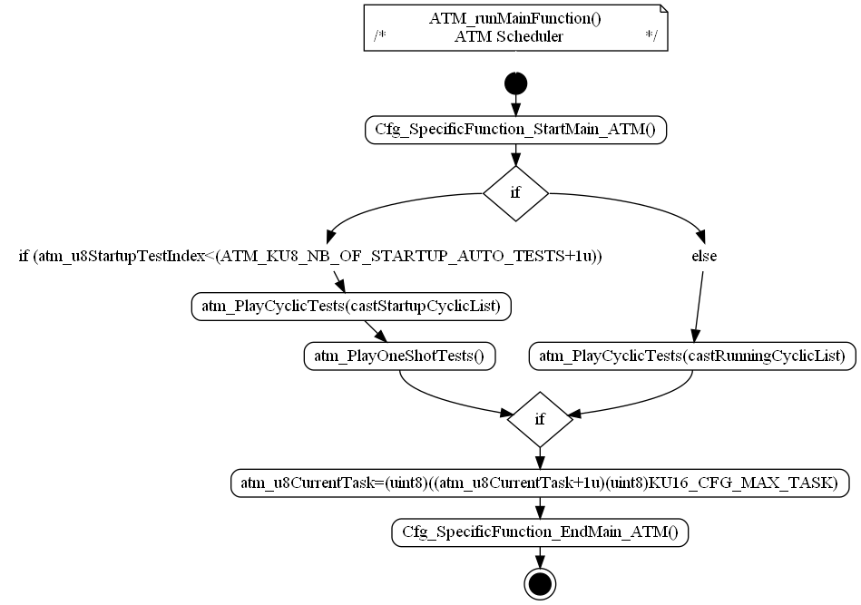

Figure : ATM_runMainFunction

### ATM_runGetTestResult

|  |  |  |
| --- | --- | --- |
| Object | | |
| Return the last test result for a specific auto-test | | |
| **Prototype** | | |
| **void** **ATM_runGetTestResult (u8AutoTestIdType** u8AutoTestId**, u8TestResultType \***u8TestResult **)** | | |
| **Input parameters** | | |
| Name | Type | Description |
| U8AutoTestId | U8AutoTestIdType | ATM auto-test ID provided in ATM_Cfg_public.h |
| **Output parameters** | | |
| Name | Type | Description |
| U8TestResult | U8TestResultType* | Possible values:   * KU8_ATM_TEST_OK * KU8_ATM_TEST_NOK   KU8_ATM_NOT_DECIDED |
| **Return value** | | |
| Type | Description | |
| NA | void | |
| **Dynamic aspect** | | |
| Who(callers) | Description | |
| Any SW module | A RTE call is needed to access this service, the link shall be done at architecture level. | |
| **Static aspect** | | |
| Read the test status from the local array. If the test ID provided in parameter is not valid, the status KU8_CFG_NB_OF_AUTOTESTS is returned | | |
| **Constrains** | | |
| NA | | |

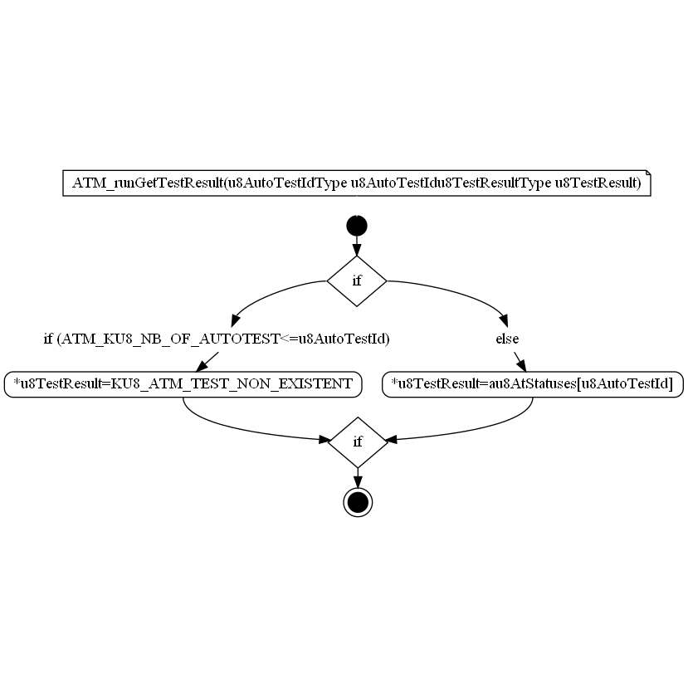

Figure : ATM_runGetTestResult

### ATM_runGetLastCriticalAutotestId

|  |  |  |
| --- | --- | --- |
| Object | | |
| The function aims at returning the last critical Autotest Id. | | |
| **Prototype** | | |
| EXPORTED void ATM_runGetLastCriticalAutotestId (UInt8 u8AutoTestId) | | |
| **Remarks** | | |
| none | | |
| **Input parameters** | | |
| Name | Type | Description |
| u8AutoTestId | UInt8 | Id of identified autotest. |
| **Output parameters** | | |
| Name | Type | Description |
| NA | NA | NA |
| **Return value** | | |
| Type | Description | |
| NA | void | |
| **Dynamic aspect** | | |
| Who(callers) | Description | |
| * | * | |
| **Static aspect** | | |
| * | | |
| **Constrains** | | |
|  | | |

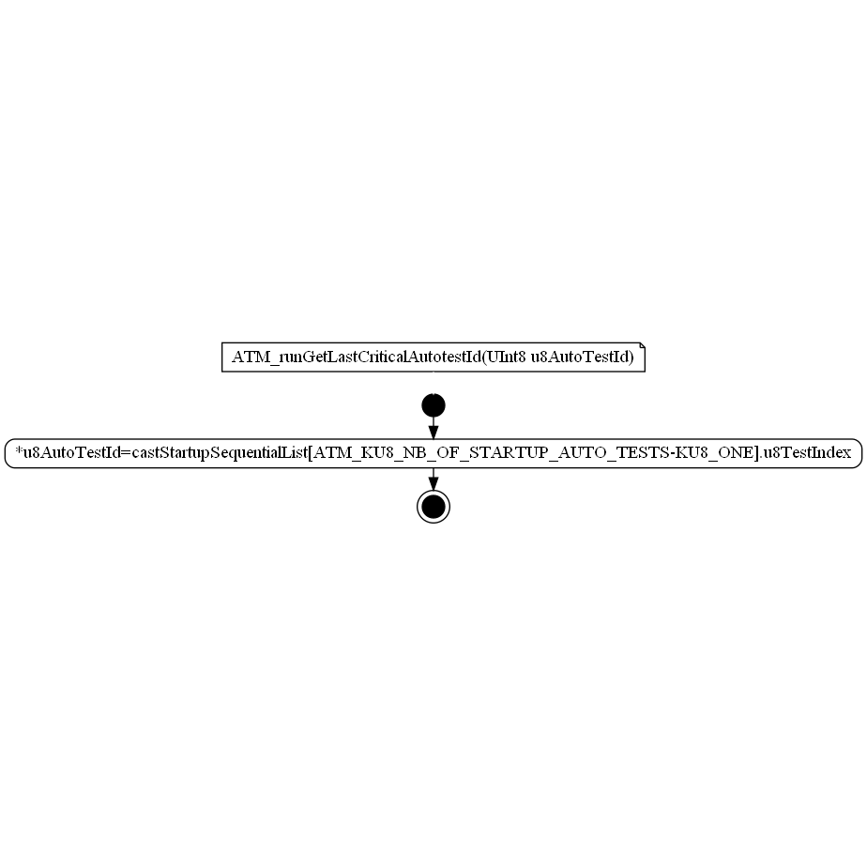

Figure : ATM_runGetLastCriticalAutotestId

### atm_executeAutoTest

|  |  |  |
| --- | --- | --- |
| Object | | |
| Execute a test by calling its callback. Send the test status to ERH | | |
| **Prototype** | | |
| **void** atm_**executeAutoTest (uint8** u8AutotestId**)** | | |
| **Input parameters** | | |
| Name | Type | Description |
| U8AutotestId | Uint8 | Index of the test in the internal configuration array |
| **Output parameters** | | |
| Name | Type | Description |
| NA | NA | NA |
| **Return value** | | |
| Type | Description | |
| NA | void | |
| **Dynamic aspect** | | |
| Who(callers) | Description | |
| ATM | Called every time a test needs to be executed | |
| **Static aspect** | | |
| Check the MMG mode before executing the test. Then notify the ERH according to the test result. | | |
| **Constrains** | | |
| NA | | |



Figure : executeAutoTest

### atm_isAutoTestEnabled

|  |  |  |
| --- | --- | --- |
| Object | | |
| This service check if an auto-test can be executed | | |
| **Prototype** | | |
| **boolean** atm_**isAutoTestEnabled (uint8** u8AutotestId**)** | | |
| **Input parameters** | | |
| Name | Type | Description |
| U8AutotestId | Uint8 | Index of the test in the internal configuration array |
| **Output parameters** | | |
| Name | Type | Description |
| NA | NA | NA |
| **Return value** | | |
| Type | Description | |
| Boolean | -B_TRUE when the test is enabled and can be executed  -B_FALSE otherwise | |
| **Dynamic aspect** | | |
| Who(callers) | Description | |
| ATM | Called every time a test needs to be executed | |
| **Static aspect** | | |
| Check if a callback is configured and if the test is enabled by configuration. When a test is disabled, the ERH is notified with a PASSED state to avoid freezing the complete sequence. | | |
| **Constrains** | | |
| Test ID must be in the correct range. | | |



Figure : atm_isAutoTestEnabled

### atm_PlayCyclicTests

|  |  |  |
| --- | --- | --- |
| Object | | |
| Sub function of ATM_runMainFunction  Treats the cyclic auto test scheduling according to the table passed as argument which concerns either the start-up cyclic tests, or the running cyclic tests. | | |
| **Prototype** | | |
| **void** **atm_PlayCyclicTests (stCyclicListEltType \***cpstCyclicList**)** | | |
| **Input parameters** | | |
| Name | Type | Description |
| cpstCyclicList | stCyclicListEltType | Head (first element) of the array containing the 5 sub-list to be played. |
| **Output parameters** | | |
| Name | Type | Description |
| NA | NA | NA |
| **Return value** | | |
| Type | Description | |
| NA | void | |
| **Dynamic aspect** | | |
| Who(callers) | Description | |
| ATM_runMainFunction | ATM Periodic main function | |
| **Static aspect** | | |
| NA | | |
| **Constrains** | | |
| The table passed as argument is expected to be constant. | | |

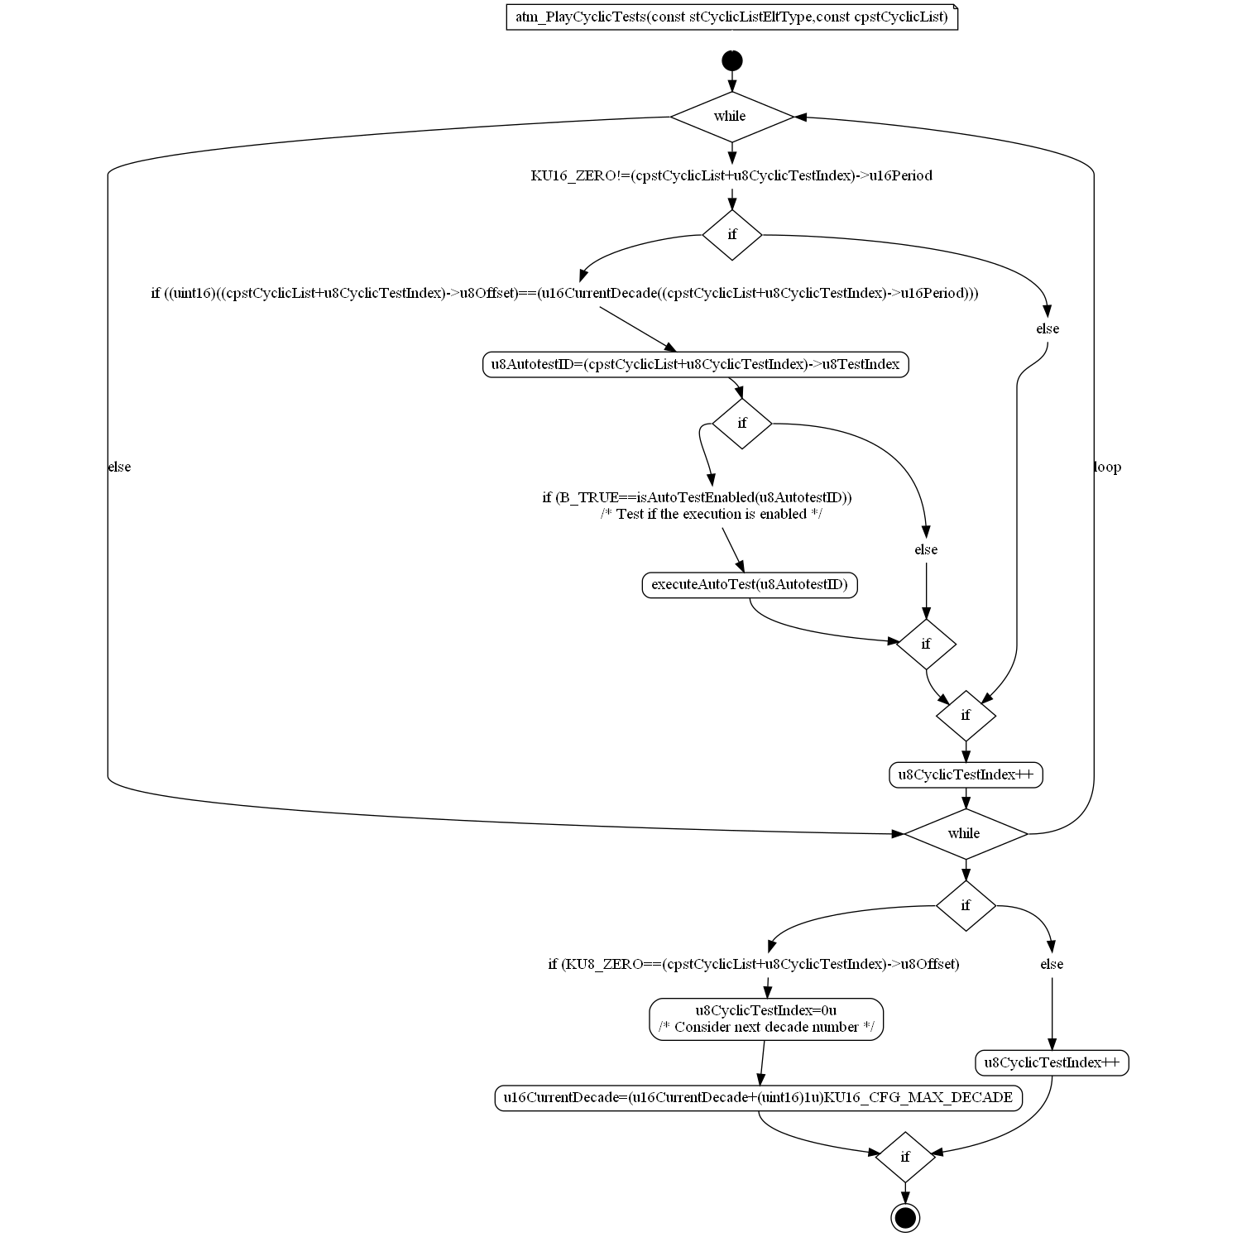

Figure : atm_PlayCyclicTests

### atm_PlayOneShotTests

|  |  |  |
| --- | --- | --- |
| Object | | |
| Sub function of ATM_runMainFunction  Treats the “one shot” sequence according to the table passed as argument which concerns either the start-up cyclic tests, or the running cyclic tests. | | |
| **Prototype** | | |
| **void** **atm_PlayOneShotTests (void)** | | |
| **Input parameters** | | |
| Name | Type | Description |
| NA | NA | NA |
| **Output parameters** | | |
| Name | Type | Description |
| NA | NA | NA |
| **Return value** | | |
| Type | Description | |
| NA | void | |
| **Dynamic aspect** | | |
| Who(callers) | Description | |
| ATM_runMainFunction | ATM Periodic main function | |
| **Static aspect** | | |
| NA | | |
| **Constrains** | | |
| NA | | |



Figure : atm_PlayOneShotTests

### ADC_cbk_CheckAdc

|  |  |  |
| --- | --- | --- |
| Object | | |
| Callback of Rte_Call_pclCheckAdc autotest to check ADC. | | |
| **Prototype** | | |
| LOCAL u8TestResultType ADC_cbk_CheckAdc (void) | | |
| **Remarks** | | |
| None | | |
| **Input parameters** | | |
| Name | Type | Description |
| NA | NA | NA |
| **Output parameters** | | |
| Name | Type | Description |
| NA | NA | NA |
| **Return value** | | |
| Type | Description | |
| u8TestResultType | u8TestResult | |
| **Dynamic aspect** | | |
| Who(callers) | Description | |
| * | * | |
| **Static aspect** | | |
| * | | |
| **Constrains** | | |
|  | | |

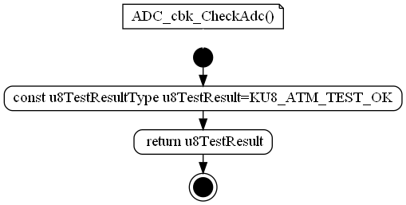

Figure : ADC_cbk_CheckAdc

### BMM_cbk_CheckHallEffectSensor

|  |  |  |
| --- | --- | --- |
| Object | | |
| Callback of Rte_Call_pclCheckHallEffectSensor AutoTest. | | |
| **Prototype** | | |
| LOCAL u8TestResultType BMM_cbk_CheckHallEffectSensor (void) | | |
| **Remarks** | | |
| None | | |
| **Input parameters** | | |
| Name | Type | Description |
| NA | NA | NA |
| **Output parameters** | | |
| Name | Type | Description |
| NA | NA | NA |
| **Return value** | | |
| Type | Description | |
| u8TestResultType | u8TestResult | |
| **Dynamic aspect** | | |
| Who(callers) | Description | |
| * | * | |
| **Static aspect** | | |
| * | | |
| **Constrains** | | |
|  | | |

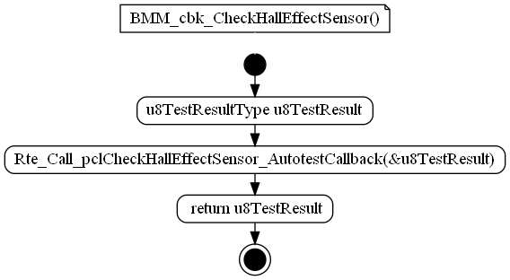

Figure : BMM_cbk_CheckHallEffectSensor

### Cfg_SpecificFunction_EndMain_ATM

|  |  |  |
| --- | --- | --- |
| Object | | |
| Configurabled function called in ATM MainFcuntion at the and of all functionalities. | | |
| **Prototype** | | |
| void Cfg_SpecificFunction_EndMain_ATM (void) | | |
| **Remarks** | | |
| None | | |
| **Input parameters** | | |
| Name | Type | Description |
| NA | NA | NA |
| **Output parameters** | | |
| Name | Type | Description |
| NA | NA | NA |
| **Return value** | | |
| Type | Description | |
| NA | void | |
| **Dynamic aspect** | | |
| Who(callers) | Description | |
| * | * | |
| **Static aspect** | | |
| * | | |
| **Constrains** | | |
|  | | |

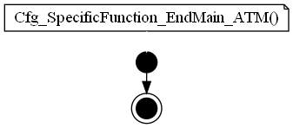

Figure : Cfg_SpecificFunction_EndMain_ATM

### Cfg_SpecificFunction_Init_ATM

|  |  |  |
| --- | --- | --- |
| Object | | |
| Configurabled function for Init, called in ATM_Init function. | | |
| **Prototype** | | |
| void Cfg_SpecificFunction_Init_ATM (void) | | |
| **Remarks** | | |
| None | | |
| **Input parameters** | | |
| Name | Type | Description |
| NA | NA | NA |
| **Output parameters** | | |
| Name | Type | Description |
| NA | NA | NA |
| **Return value** | | |
| Type | Description | |
| NA | void | |
| **Dynamic aspect** | | |
| Who(callers) | Description | |
| * | * | |
| **Static aspect** | | |
| * | | |
| **Constrains** | | |
|  | | |

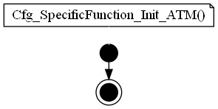

Figure : Cfg_SpecificFunction_Init_ATM

### Cfg_SpecificFunction_Shutdown_ATM

|  |  |  |
| --- | --- | --- |
| Object | | |
| Configurabled function for Shutdown called in ATM_Shutdown function.. | | |
| **Prototype** | | |
| void Cfg_SpecificFunction_Shutdown_ATM (void) | | |
| **Remarks** | | |
| None | | |
| **Input parameters** | | |
| Name | Type | Description |
| NA | NA | NA |
| **Output parameters** | | |
| Name | Type | Description |
| NA | NA | NA |
| **Return value** | | |
| Type | Description | |
| NA | void | |
| **Dynamic aspect** | | |
| Who(callers) | Description | |
| * | * | |
| **Static aspect** | | |
| * | | |
| **Constrains** | | |
|  | | |

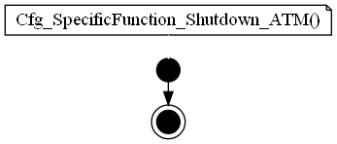

Figure : Cfg_SpecificFunction_Shutdown_ATM

### Cfg_SpecificFunction_StartMain_ATM

|  |  |  |
| --- | --- | --- |
| Object | | |
| Configurabled function called in ATM MainFcuntion , before any other functionalities. | | |
| **Prototype** | | |
| void Cfg_SpecificFunction_StartMain_ATM (void) | | |
| **Remarks** | | |
| None | | |
| **Input parameters** | | |
| Name | Type | Description |
| NA | NA | NA |
| **Output parameters** | | |
| Name | Type | Description |
| NA | NA | NA |
| **Return value** | | |
| Type | Description | |
| NA | void | |
| **Dynamic aspect** | | |
| Who(callers) | Description | |
| * | * | |
| **Static aspect** | | |
| * | | |
| **Constrains** | | |
|  | | |

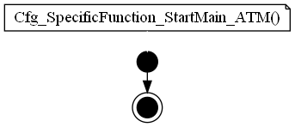

Figure : Cfg_SpecificFunction_StartMain_ATM

### CIL_cbk_CheckImplausibleData_Ignition

|  |  |  |
| --- | --- | --- |
| Object | | |
| Callback of CIL_Autotest_CheckImplausibleData_Ignition AutoTest. | | |
| **Prototype** | | |
| LOCAL u8TestResultType CIL_cbk_CheckImplausibleData_Ignition (void) | | |
| **Remarks** | | |
| None | | |
| **Input parameters** | | |
| Name | Type | Description |
| NA | NA | NA |
| **Output parameters** | | |
| Name | Type | Description |
| NA | NA | NA |
| **Return value** | | |
| Type | Description | |
| u8TestResultType | u8TestResult | |
| **Dynamic aspect** | | |
| Who(callers) | Description | |
| * | * | |
| **Static aspect** | | |
| * | | |
| **Constrains** | | |
|  | | |

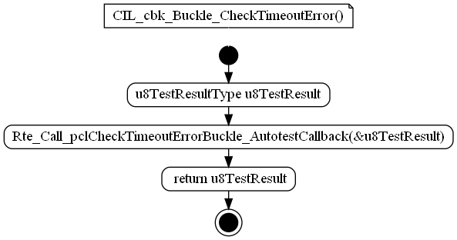

Figure : CIL_cbk_CheckImplausibleData_Ignition

### CIL_cbk_Buckle_CheckTimeoutError

|  |  |  |
| --- | --- | --- |
| Object | | |
| Callback of Rte_Call_pclCheckTimeoutErrorBuckle_AutotestCallback AutoTest. | | |
| **Prototype** | | |
| LOCAL u8TestResultType CIL_cbk_Buckle_CheckTimeoutError (void) | | |
| **Remarks** | | |
| None | | |
| **Input parameters** | | |
| Name | Type | Description |
| NA | NA | NA |
| **Output parameters** | | |
| Name | Type | Description |
| NA | NA | NA |
| **Return value** | | |
| Type | Description | |
| u8TestResultType | u8TestResult | |
| **Dynamic aspect** | | |
| Who(callers) | Description | |
| * | * | |
| **Static aspect** | | |
| * | | |
| **Constrains** | | |
|  | | |

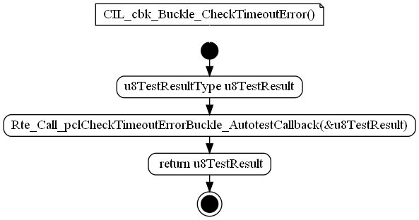

Figure : CIL_cbk_Buckle_CheckTimeoutError

### CIL_cbk_CheckImplausibleData_Buckle

|  |  |  |
| --- | --- | --- |
| Object | | |
| Callback of CIL_cbk_CheckImplausibleData_Buckle AutoTest. | | |
| **Prototype** | | |
| LOCAL u8TestResultType CIL_cbk_CheckImplausibleData_Buckle (void) | | |
| **Remarks** | | |
| None | | |
| **Input parameters** | | |
| Name | Type | Description |
| NA | NA | NA |
| **Output parameters** | | |
| Name | Type | Description |
| NA | NA | NA |
| **Return value** | | |
| Type | Description | |
| u8TestResultType | u8TestResult | |
| **Dynamic aspect** | | |
| Who(callers) | Description | |
| * | * | |
| **Static aspect** | | |
| * | | |
| **Constrains** | | |
|  | | |

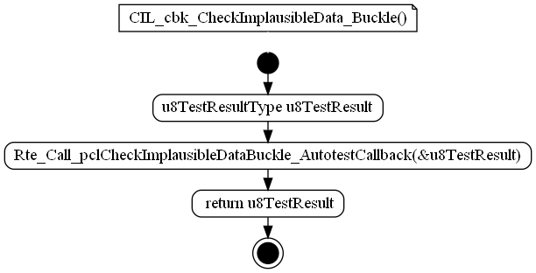

Figure : CIL_cbk_CheckImplausibleData_Buckle

### CIL_cbk_CheckImplausibleData_Presafe

|  |  |  |
| --- | --- | --- |
| Object | | |
| Callback of CIL_Autotest_CheckImplausibleData_Presafe AutoTest. | | |
| **Prototype** | | |
| LOCAL u8TestResultType CIL_cbk_CheckImplausibleData_Presafe (void) | | |
| **Remarks** | | |
| None | | |
| **Input parameters** | | |
| Name | Type | Description |
| NA | NA | NA |
| **Output parameters** | | |
| Name | Type | Description |
| NA | NA | NA |
| **Return value** | | |
| Type | Description | |
| u8TestResultType | u8TestResult | |
| **Dynamic aspect** | | |
| Who(callers) | Description | |
| * | * | |
| **Static aspect** | | |
| * | | |
| **Constrains** | | |
|  | | |

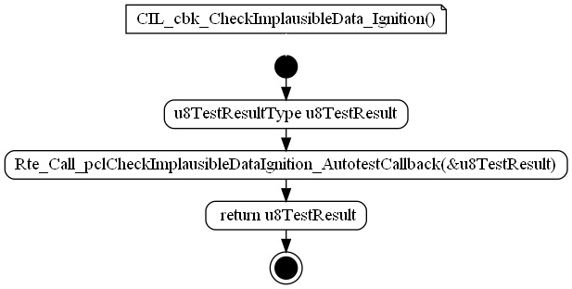

Figure : CIL_cbk_CheckImplausibleData_Presafe

### CIL_cbk_Presafe_CheckTimeoutError

|  |  |  |
| --- | --- | --- |
| Object | | |
| Callback of Rte_Call_pclCheckTimeoutError_AutotestCallbacks AutoTest. | | |
| **Prototype** | | |
| LOCAL u8TestResultType CIL_cbk_Presafe_CheckTimeoutError (void) | | |
| **Remarks** | | |
| None | | |
| **Input parameters** | | |
| Name | Type | Description |
| NA | NA | NA |
| **Output parameters** | | |
| Name | Type | Description |
| NA | NA | NA |
| **Return value** | | |
| Type | Description | |
| u8TestResultType | u8TestResult | |
| **Dynamic aspect** | | |
| Who(callers) | Description | |
| * | * | |
| **Static aspect** | | |
| * | | |
| **Constrains** | | |
|  | | |

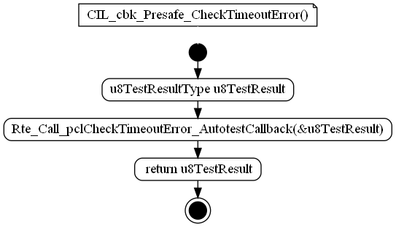

Figure : CIL_cbk_Presafe_CheckTimeoutError

### EOL_cbk_CheckProductEndOfLifeComfort

|  |  |  |
| --- | --- | --- |
| Object | | |
| Callback of Rte_Call_pclCheckProductEndOfLifeComfort_AutotestCallback AutoTest. | | |
| **Prototype** | | |
| LOCAL u8TestResultType EOL_cbk_CheckProductEndOfLifeComfort (void) | | |
| **Remarks** | | |
| None | | |
| **Input parameters** | | |
| Name | Type | Description |
| NA | NA | NA |
| **Output parameters** | | |
| Name | Type | Description |
| NA | NA | NA |
| **Return value** | | |
| Type | Description | |
| u8TestResultType | u8TestResult | |
| **Dynamic aspect** | | |
| Who(callers) | Description | |
| * | * | |
| **Static aspect** | | |
| * | | |
| **Constrains** | | |
|  | | |

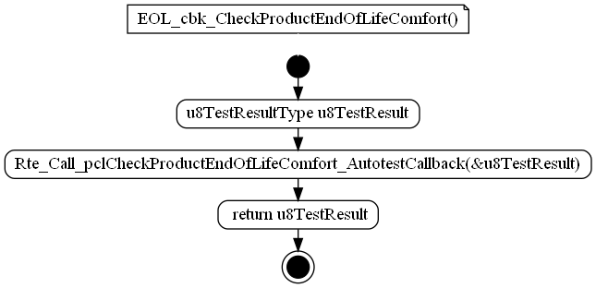

Figure : EOL_cbk_CheckProductEndOfLifeComfort

### EOL_cbk_CheckProductEndOfLifeHighForce

|  |  |  |
| --- | --- | --- |
| Object | | |
| Callback of Rte_Call_pclCheckProductEndOfLifeHighForce AutoTest. | | |
| **Prototype** | | |
| LOCAL u8TestResultType EOL_cbk_CheckProductEndOfLifeHighForce (void) | | |
| **Remarks** | | |
| None | | |
| **Input parameters** | | |
| Name | Type | Description |
| NA | NA | NA |
| **Output parameters** | | |
| Name | Type | Description |
| NA | NA | NA |
| **Return value** | | |
| Type | Description | |
| u8TestResultType | u8TestResult | |
| **Dynamic aspect** | | |
| Who(callers) | Description | |
| * | * | |
| **Static aspect** | | |
| * | | |
| **Constrains** | | |
|  | | |

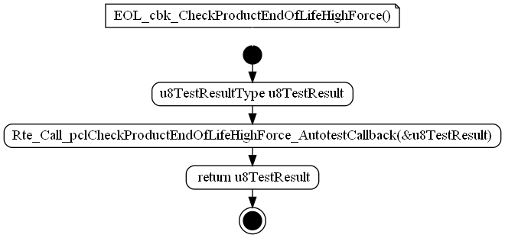

Figure : EOL_cbk_CheckProductEndOfLifeHighForce

### EOL_cbk_CheckProductEndOfLifeLowForce

|  |  |  |
| --- | --- | --- |
| Object | | |
| Callback of Rte_Call_pclCheckProductEndOfLifeLowForce AutoTest. | | |
| **Prototype** | | |
| LOCAL u8TestResultType EOL_cbk_CheckProductEndOfLifeLowForce (void) | | |
| **Remarks** | | |
| None | | |
| **Input parameters** | | |
| Name | Type | Description |
| NA | NA | NA |
| **Output parameters** | | |
| Name | Type | Description |
| NA | NA | NA |
| **Return value** | | |
| Type | Description | |
| u8TestResultType | u8TestResult | |
| **Dynamic aspect** | | |
| Who(callers) | Description | |
| * | * | |
| **Static aspect** | | |
| * | | |
| **Constrains** | | |
|  | | |

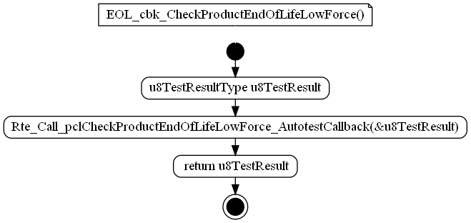

Figure :EOL_cbk_CheckProductEndOfLifeLowForce

### PAL_cbk_CheckCommandConsistency

|  |  |  |
| --- | --- | --- |
| Object | | |
| Callback of Rte_Call_pclCheckCommandConsistency autotest. | | |
| **Prototype** | | |
| LOCAL u8TestResultType PAL_cbk_CheckCommandConsistency (void) | | |
| **Remarks** | | |
| None | | |
| **Input parameters** | | |
| Name | Type | Description |
| NA | NA | NA |
| **Output parameters** | | |
| Name | Type | Description |
| NA | NA | NA |
| **Return value** | | |
| Type | Description | |
| u8TestResultType | u8TestResult | |
| **Dynamic aspect** | | |
| Who(callers) | Description | |
| * | * | |
| **Static aspect** | | |
| * | | |
| **Constrains** | | |
|  | | |

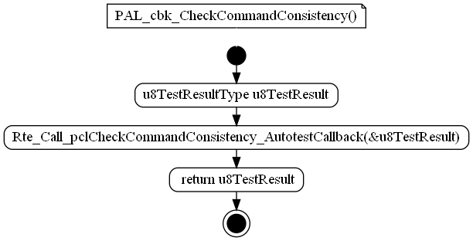

Figure : PAL_cbk_CheckCommandConsistency

### PAL_cbk_CheckHighSideSwRegulation

|  |  |  |
| --- | --- | --- |
| Object | | |
| Callback of Rte_Call_pclCheckHighSideSwRegulation autotest to test the High Side Switch regulation. | | |
| **Prototype** | | |
| LOCAL u8TestResultType PAL_cbk_CheckHighSideSwRegulation (void) | | |
| **Remarks** | | |
| None | | |
| **Input parameters** | | |
| Name | Type | Description |
| NA | NA | NA |
| **Output parameters** | | |
| Name | Type | Description |
| NA | NA | NA |
| **Return value** | | |
| Type | Description | |
| u8TestResultType | u8TestResult | |
| **Dynamic aspect** | | |
| Who(callers) | Description | |
| * | * | |
| **Static aspect** | | |
| * | | |
| **Constrains** | | |
|  | | |

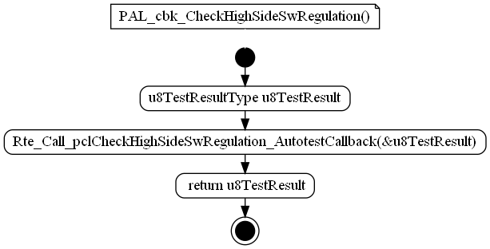

Figure : PAL_cbk_CheckHighSideSwRegulation

### PAL_cbk_CheckHWSelfProtection

|  |  |  |
| --- | --- | --- |
| Object | | |
| Callback of Rte_Call_pclCheckHWSelfProtection autotest. | | |
| **Prototype** | | |
| LOCAL u8TestResultType PAL_cbk_CheckHWSelfProtection (void) | | |
| **Remarks** | | |
| None | | |
| **Input parameters** | | |
| Name | Type | Description |
| NA | NA | NA |
| **Output parameters** | | |
| Name | Type | Description |
| NA | NA | NA |
| **Return value** | | |
| Type | Description | |
| u8TestResultType | u8TestResult | |
| **Dynamic aspect** | | |
| Who(callers) | Description | |
| * | * | |
| **Static aspect** | | |
| * | | |
| **Constrains** | | |
|  | | |

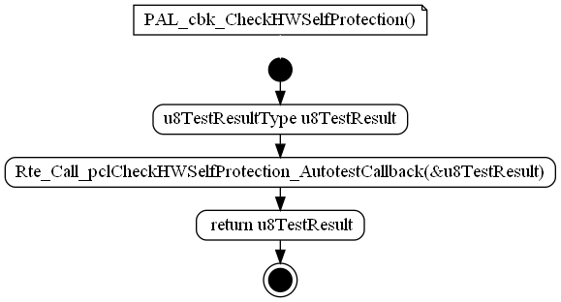

Figure : PAL_cbk_CheckHWSelfProtection

### PAL_cbk_CheckMosfetHighSC

|  |  |  |
| --- | --- | --- |
| Object | | |
| Callback of Rte_Call_pclCheckMosfetHighSC autotest. | | |
| **Prototype** | | |
| LOCAL u8TestResultType PAL_cbk_CheckMosfetHighSC (void) | | |
| **Remarks** | | |
| None | | |
| **Input parameters** | | |
| Name | Type | Description |
| NA | NA | NA |
| **Output parameters** | | |
| Name | Type | Description |
| NA | NA | NA |
| **Return value** | | |
| Type | Description | |
| u8TestResultType | u8TestResult | |
| **Dynamic aspect** | | |
| Who(callers) | Description | |
| * | * | |
| **Static aspect** | | |
| * | | |
| **Constrains** | | |
|  | | |

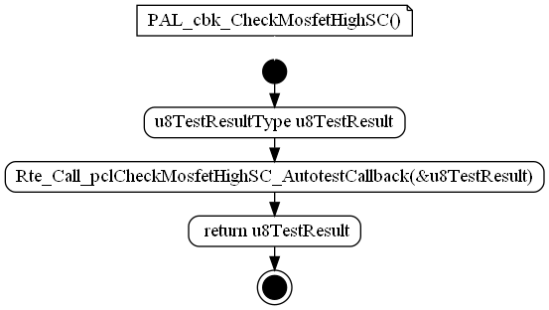

Figure : PAL_cbk_CheckMosfetHighSC

### PAL_cbk_CheckMosfetLowSC

|  |  |  |
| --- | --- | --- |
| Object | | |
| Callback of Rte_Call_pclCheckMosfetLowSC autotest. | | |
| **Prototype** | | |
| LOCAL u8TestResultType PAL_cbk_CheckMosfetLowSC (void) | | |
| **Remarks** | | |
| None | | |
| **Input parameters** | | |
| Name | Type | Description |
| NA | NA | NA |
| **Output parameters** | | |
| Name | Type | Description |
| NA | NA | NA |
| **Return value** | | |
| Type | Description | |
| u8TestResultType | u8TestResult | |
| **Dynamic aspect** | | |
| Who(callers) | Description | |
| * | * | |
| **Static aspect** | | |
| * | | |
| **Constrains** | | |
|  | | |

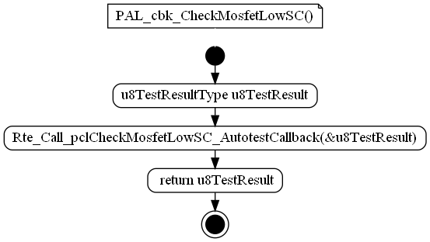

Figure : PAL_cbk_CheckMosfetLowSC

### PAL_cbk_CheckMosfetOCAT

|  |  |  |
| --- | --- | --- |
| Object | | |
| Callback of Rte_Call_pclCheckMosfetOCA autotest. | | |
| **Prototype** | | |
| LOCAL u8TestResultType PAL_cbk_CheckMosfetOCAT (void) | | |
| **Remarks** | | |
| None | | |
| **Input parameters** | | |
| Name | Type | Description |
| NA | NA | NA |
| **Output parameters** | | |
| Name | Type | Description |
| NA | NA | NA |
| **Return value** | | |
| Type | Description | |
| u8TestResultType | u8TestResult | |
| **Dynamic aspect** | | |
| Who(callers) | Description | |
| * | * | |
| **Static aspect** | | |
| * | | |
| **Constrains** | | |
|  | | |

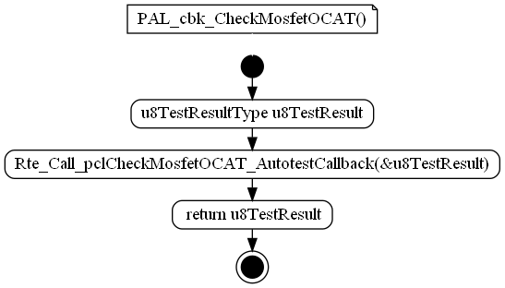

Figure : PAL_cbk_CheckMosfetOCAT

### PAL_cbk_CheckMotorConnection

|  |  |  |
| --- | --- | --- |
| Object | | |
| Callback of Rte_Call_pclCheckMotorConnection autotest. | | |
| **Prototype** | | |
| s LOCAL u8TestResultType PAL_cbk_CheckMotorConnection (void) | | |
| **Remarks** | | |
| None | | |
| **Input parameters** | | |
| Name | Type | Description |
| NA | NA | NA |
| **Output parameters** | | |
| Name | Type | Description |
| NA | NA | NA |
| **Return value** | | |
| Type | Description | |
| u8TestResultType | u8TestResult | |
| **Dynamic aspect** | | |
| Who(callers) | Description | |
| * | * | |
| **Static aspect** | | |
| * | | |
| **Constrains** | | |
|  | | |

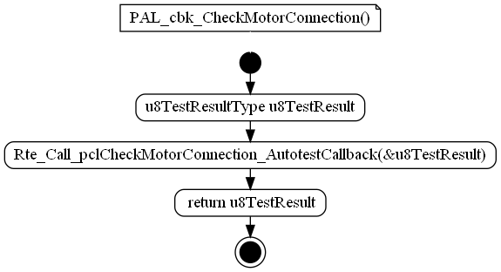

Figure : PAL_cbk_CheckMotorConnection

### PAL_cbk_CheckMotorCurrent

|  |  |  |
| --- | --- | --- |
| Object | | |
| Callback of Rte_Call_pclCheckMotorCurrent autotest. | | |
| **Prototype** | | |
| LOCAL u8TestResultType PAL_cbk_CheckMotorCurrent (void) | | |
| **Remarks** | | |
| None | | |
| **Input parameters** | | |
| Name | Type | Description |
| NA | NA | NA |
| **Output parameters** | | |
| Name | Type | Description |
| NA | NA | NA |
| **Return value** | | |
| Type | Description | |
| u8TestResultType | u8TestResult | |
| **Dynamic aspect** | | |
| Who(callers) | Description | |
| * | * | |
| **Static aspect** | | |
| * | | |
| **Constrains** | | |
|  | | |

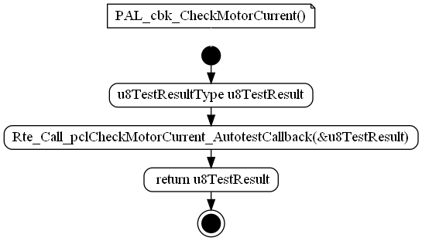

Figure : PAL_cbk_CheckMotorCurrent

### PAL_cbk_CheckMotorDisengagement

|  |  |  |
| --- | --- | --- |
| Object | | |
| Callback of Rte_Call_pclCheckMotorDisengagement autotest. | | |
| **Prototype** | | |
| LOCAL u8TestResultType PAL_cbk_CheckMotorDisengagement (void) | | |
| **Remarks** | | |
| None | | |
| **Input parameters** | | |
| Name | Type | Description |
| NA | NA | NA |
| **Output parameters** | | |
| Name | Type | Description |
| NA | NA | NA |
| **Return value** | | |
| Type | Description | |
| u8TestResultType | u8TestResult | |
| **Dynamic aspect** | | |
| Who(callers) | Description | |
| * | * | |
| **Static aspect** | | |
| * | | |
| **Constrains** | | |
|  | | |

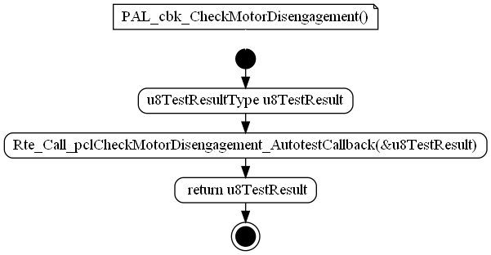

Figure : PAL_cbk_CheckMotorDisengagement

### PAL_cbk_CheckMotorPowerOrder

|  |  |  |
| --- | --- | --- |
| Object | | |
| Callback of Rte_Call_pclCheckMotorPowerOrder AutoTest. | | |
| **Prototype** | | |
| LOCAL u8TestResultType PAL_cbk_CheckMotorPowerOrder (void) | | |
| **Remarks** | | |
| None | | |
| **Input parameters** | | |
| Name | Type | Description |
| NA | NA | NA |
| **Output parameters** | | |
| Name | Type | Description |
| NA | NA | NA |
| **Return value** | | |
| Type | Description | |
| u8TestResultType | u8TestResult | |
| **Dynamic aspect** | | |
| Who(callers) | Description | |
| * | * | |
| **Static aspect** | | |
| * | | |
| **Constrains** | | |
|  | | |

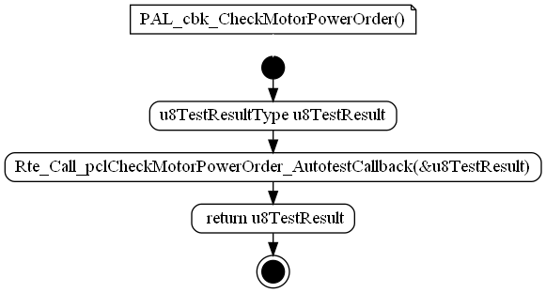

Figure : PAL_cbk_CheckMotorPowerOrder

### PAL_cbk_CheckMotorSC

|  |  |  |
| --- | --- | --- |
| Object | | |
| Callback of Rte_Call_pclCheckMotorSC AutoTest. | | |
| **Prototype** | | |
| LOCAL u8TestResultType PAL_cbk_CheckMotorSC (void) | | |
| **Remarks** | | |
| None | | |
| **Input parameters** | | |
| Name | Type | Description |
| NA | NA | NA |
| **Output parameters** | | |
| Name | Type | Description |
| NA | NA | NA |
| **Return value** | | |
| Type | Description | |
| u8TestResultType | u8TestResult | |
| **Dynamic aspect** | | |
| Who(callers) | Description | |
| * | * | |
| **Static aspect** | | |
| * | | |
| **Constrains** | | |
|  | | |

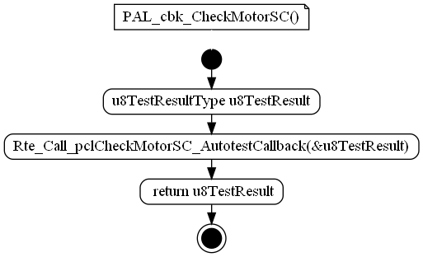

Figure : PAL_cbk_CheckMotorSC

### PAL_cbk_CheckMotorThermalProctection

|  |  |  |
| --- | --- | --- |
| Object | | |
| Callback of Rte_Call_pclCheckMotorThermalProctection - SWSelfProtection AutoTest. | | |
| **Prototype** | | |
| LOCAL u8TestResultType PAL_cbk_CheckMotorThermalProctection (void) | | |
| **Remarks** | | |
| None | | |
| **Input parameters** | | |
| Name | Type | Description |
| NA | NA | NA |
| **Output parameters** | | |
| Name | Type | Description |
| NA | NA | NA |
| **Return value** | | |
| Type | Description | |
| u8TestResultType | u8TestResult | |
| **Dynamic aspect** | | |
| Who(callers) | Description | |
| * | * | |
| **Static aspect** | | |
| * | | |
| **Constrains** | | |
|  | | |

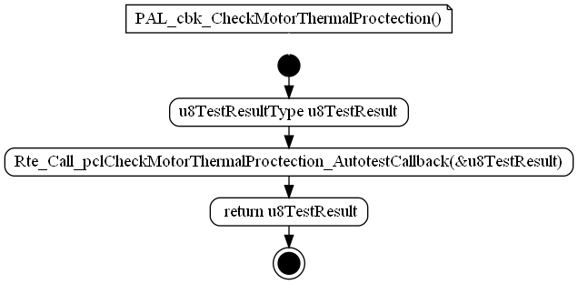

Figure : PAL_cbk_CheckMotorThermalProctection

### PMP_cbk_CheckPowerSupplyOV

|  |  |  |
| --- | --- | --- |
| Object | | |
| Callback of Rte_Call_pclCheckPowerSupplyOV AutoTest. | | |
| **Prototype** | | |
| LOCAL u8TestResultType PMP_cbk_CheckPowerSupplyOV (void) | | |
| **Remarks** | | |
| None | | |
| **Input parameters** | | |
| Name | Type | Description |
| NA | NA | NA |
| **Output parameters** | | |
| Name | Type | Description |
| NA | NA | NA |
| **Return value** | | |
| Type | Description | |
| u8TestResultType | u8TestResult | |
| **Dynamic aspect** | | |
| Who(callers) | Description | |
| * | * | |
| **Static aspect** | | |
| * | | |
| **Constrains** | | |
|  | | |

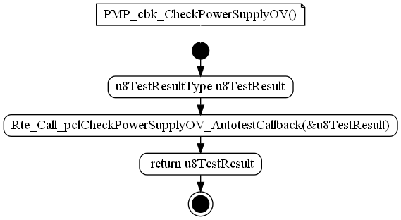

Figure : PMP_cbk_CheckPowerSupplyOV

### PMP_cbk_CheckPowerSupplyOVDuringActivation

|  |  |  |
| --- | --- | --- |
| Object | | |
| Callback of Rte_Call_pclCheckPowerSupplyOVDuringActivation AutoTest. | | |
| **Prototype** | | |
| LOCAL u8TestResultType PMP_cbk_CheckPowerSupplyOVDuringActivation (void) | | |
| **Remarks** | | |
| None | | |
| **Input parameters** | | |
| Name | Type | Description |
| NA | NA | NA |
| **Output parameters** | | |
| Name | Type | Description |
| NA | NA | NA |
| **Return value** | | |
| Type | Description | |
| u8TestResultType | u8TestResult | |
| **Dynamic aspect** | | |
| Who(callers) | Description | |
| * | * | |
| **Static aspect** | | |
| * | | |
| **Constrains** | | |
|  | | |

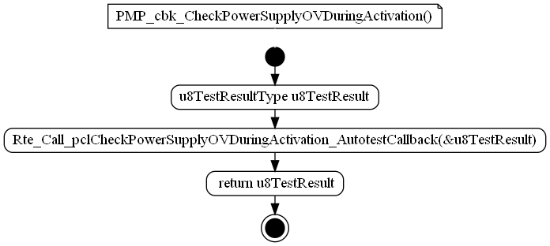

Figure : PMP_cbk_CheckPowerSupplyOVDuringActivation

### PMP_cbk_CheckPowerSupplyUV

|  |  |  |
| --- | --- | --- |
| Object | | |
| Callback of Rte_Call_pclCheckPowerSupplyUV AutoTest. | | |
| **Prototype** | | |
| LOCAL u8TestResultType PMP_cbk_CheckPowerSupplyUV (void) | | |
| **Remarks** | | |
| None | | |
| **Input parameters** | | |
| Name | Type | Description |
| NA | NA | NA |
| **Output parameters** | | |
| Name | Type | Description |
| NA | NA | NA |
| **Return value** | | |
| Type | Description | |
| u8TestResultType | u8TestResult | |
| **Dynamic aspect** | | |
| Who(callers) | Description | |
| * | * | |
| **Static aspect** | | |
| * | | |
| **Constrains** | | |
|  | | |

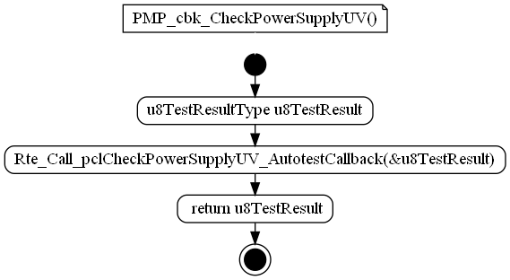

Figure : PMP_cbk_CheckPowerSupplyUV

### PMP_cbk_CheckPowerSupplyUVDuringActivation

|  |  |  |
| --- | --- | --- |
| Object | | |
| Callback of Rte_Call_pclCheckPowerSupplyUVDuringActivation AutoTest. | | |
| **Prototype** | | |
| LOCAL u8TestResultType PMP_cbk_CheckPowerSupplyUVDuringActivation (void) | | |
| **Remarks** | | |
| None | | |
| **Input parameters** | | |
| Name | Type | Description |
| NA | NA | NA |
| **Output parameters** | | |
| Name | Type | Description |
| NA | NA | NA |
| **Return value** | | |
| Type | Description | |
| u8TestResultType | u8TestResult | |
| **Dynamic aspect** | | |
| Who(callers) | Description | |
| * | * | |
| **Static aspect** | | |
| * | | |
| **Constrains** | | |
|  | | |

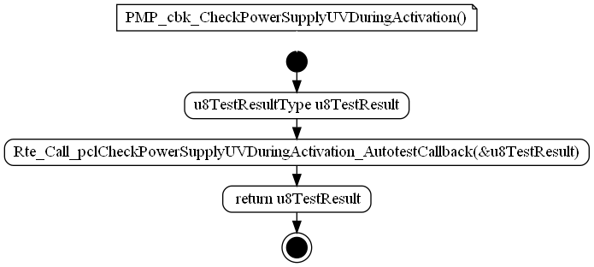

Figure : PMP_cbk_CheckPowerSupplyUVDuringActivation

### PMP_cbk_CheckTemperatureSensor

|  |  |  |
| --- | --- | --- |
| Object | | |
| Callback of Rte_Call_pclCheckTemperatureSensor AutoTest. | | |
| **Prototype** | | |
| LOCAL u8TestResultType PMP_cbk_CheckTemperatureSensor (void) | | |
| **Remarks** | | |
| None | | |
| **Input parameters** | | |
| Name | Type | Description |
| NA | NA | NA |
| **Output parameters** | | |
| Name | Type | Description |
| NA | NA | NA |
| **Return value** | | |
| Type | Description | |
| u8TestResultType | u8TestResult | |
| **Dynamic aspect** | | |
| Who(callers) | Description | |
| * | * | |
| **Static aspect** | | |
| * | | |
| **Constrains** | | |
|  | | |

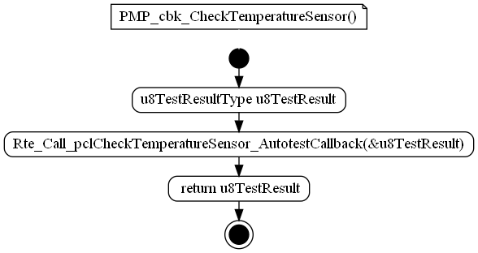

Figure : PMP_cbk_CheckTemperatureSensor

### RCM_cbk_ExtWatchdogTest_Autotest

|  |  |  |
| --- | --- | --- |
| Object | | |
| Callback of Rte_Call_pclRunExtWatchogTest autotest to check an unexpected reset. | | |
| **Prototype** | | |
| LOCAL u8TestResultType RCM_cbk_ExtWatchdogTest_Autotest (void) | | |
| **Remarks** | | |
| None | | |
| **Input parameters** | | |
| Name | Type | Description |
| NA | NA | NA |
| **Output parameters** | | |
| Name | Type | Description |
| NA | NA | NA |
| **Return value** | | |
| Type | Description | |
| u8TestResultType | u8TestResult | |
| **Dynamic aspect** | | |
| Who(callers) | Description | |
| * | * | |
| **Static aspect** | | |
| * | | |
| **Constrains** | | |
|  | | |

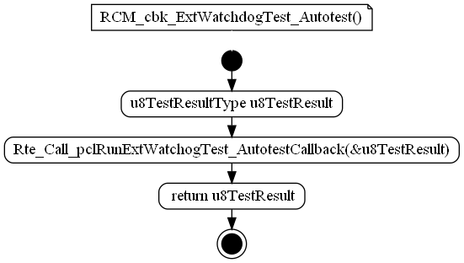

Figure : RCM_cbk_ExtWatchdogTest_Autotest

### RCM_cbk_RunResetCause_Autotest

|  |  |  |
| --- | --- | --- |
| Object | | |
| Callback of Rte_Call_pclRunResetCause autotest to check if an unexpected reset cause has been detected. | | |
| **Prototype** | | |
| LOCAL u8TestResultType RCM_cbk_RunResetCause_Autotest (void) | | |
| **Remarks** | | |
| None | | |
| **Input parameters** | | |
| Name | Type | Description |
| NA | NA | NA |
| **Output parameters** | | |
| Name | Type | Description |
| NA | NA | NA |
| **Return value** | | |
| Type | Description | |
| u8TestResultType | u8TestResult | |
| **Dynamic aspect** | | |
| Who(callers) | Description | |
| * | * | |
| **Static aspect** | | |
| * | | |
| **Constrains** | | |
|  | | |

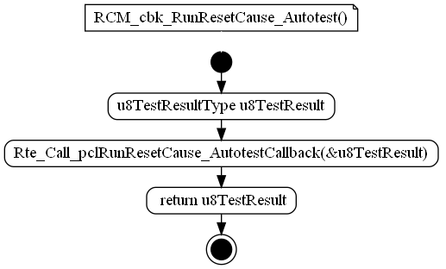

Figure : RCM_cbk_RunResetCause_Autotest

### CIL_cbk_SteeringConfiguration

|  |  |  |  |
| --- | --- | --- | --- |
| Object | | | |
| Callback of CIL_Autotest_CheckSteeringConfiguration AutoTest. | | | |
| **Prototype** | | | |
| LOCAL u8TestResultType CIL_cbk_SteeringConfiguration (void) | | | |
| **Parameters** | | | |
| void | | | |
| **Remarks** | | | |
| None | | | |
| **Input parameters** | | | |
| Name | Type | Description | Range |
| NA | NA | NA | NA |
| **Output parameters** | | | |
| Name | Type | Description | Range |
| NA | NA | NA | NA |
| **Return value** | | | |
| Type | Description | | |
| u8TestResultType | u8TestResult | | |
| **Dynamic aspect** | | | |
| Who(callers) | Description | | |
| * | * | | |
| **Static aspect** | | | |
| * | | | |
| **Constrains** | | | |
|  | | | |

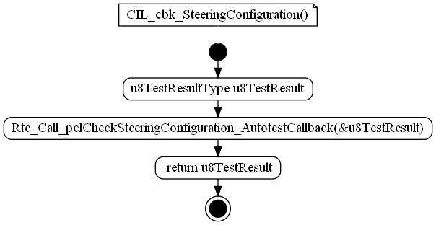

Figure :CIL_cbk_SteeringConfiguration

### CIL_cbk_CheckImplausibleData_ORC

|  |  |  |  |
| --- | --- | --- | --- |
| Object | | | |
| Callback of CIL_Autotest_CheckImplausibleData_ORC AutoTest. | | | |
| **Prototype** | | | |
| LOCAL u8TestResultType CIL_cbk_CheckImplausibleData_ORC (void) | | | |
| **Parameters** | | | |
| void | | | |
| **Remarks** | | | |
| None | | | |
| **Input parameters** | | | |
| Name | Type | Description | Range |
| NA | NA | NA | NA |
| **Output parameters** | | | |
| Name | Type | Description | Range |
| NA | NA | NA | NA |
| **Return value** | | | |
| Type | Description | | |
| u8TestResultType | u8TestResult | | |
| **Dynamic aspect** | | | |
| Who(callers) | Description | | |
| * | * | | |
| **Static aspect** | | | |
| * | | | |
| **Constrains** | | | |
|  | | | |

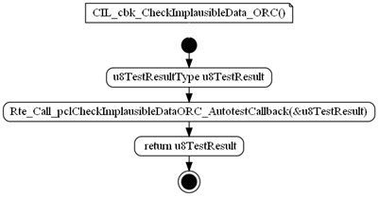

Figure :CIL_cbk_CheckImplausibleData_ORC

### CIL_cbk_CheckImplausibleData_Powertrain_Drv

|  |  |  |  |
| --- | --- | --- | --- |
| Object | | | |
| Callback of CIL_Autotest_CheckImplausibleData_Powertrain_Drv AutoTest. | | | |
| **Prototype** | | | |
| LOCAL u8TestResultType CIL_cbk_CheckImplausibleData_Powertrain_Drv (void) | | | |
| **Parameters** | | | |
| void | | | |
| **Remarks** | | | |
| None | | | |
| **Input parameters** | | | |
| Name | Type | Description | Range |
| NA | NA | NA | NA |
| **Output parameters** | | | |
| Name | Type | Description | Range |
| NA | NA | NA | NA |
| **Return value** | | | |
| Type | Description | | |
| u8TestResultType | u8TestResult | | |
| **Dynamic aspect** | | | |
| Who(callers) | Description | | |
| * | * | | |
| **Static aspect** | | | |
| * | | | |
| **Constrains** | | | |
|  | | | |

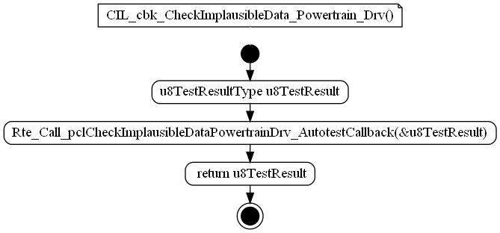

Figure :CIL_cbk_CheckImplausibleData_Powertrain_Drv

### CIL_cbk_CheckTimeoutError_API

|  |  |  |  |
| --- | --- | --- | --- |
| Object | | | |
| Callback of CIL_Autotest_CheckTimeoutError_API AutoTest. | | | |
| **Prototype** | | | |
| LOCAL u8TestResultType CIL_cbk_CheckTimeoutError_API (void) | | | |
| **Parameters** | | | |
| void | | | |
| **Remarks** | | | |
| None | | | |
| **Input parameters** | | | |
| Name | Type | Description | Range |
| NA | NA | NA | NA |
| **Output parameters** | | | |
| Name | Type | Description | Range |
| NA | NA | NA | NA |
| **Return value** | | | |
| Type | Description | | |
| u8TestResultType | u8TestResult | | |
| **Dynamic aspect** | | | |
| Who(callers) | Description | | |
| * | * | | |
| **Static aspect** | | | |
| * | | | |
| **Constrains** | | | |
|  | | | |

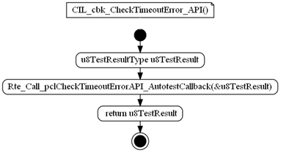

Figure :CIL_cbk_CheckTimeoutError_API

### CIL_cbk_CheckTimeoutError_BelthandoverL

|  |  |  |  |
| --- | --- | --- | --- |
| Object | | | |
| Callback of CIL_Autotest_CheckTimeoutError_BelthandoverL AutoTest. | | | |
| **Prototype** | | | |
| LOCAL u8TestResultType CIL_cbk_CheckTimeoutError_BelthandoverL (void) | | | |
| **Parameters** | | | |
| void | | | |
| **Remarks** | | | |
| None | | | |
| **Input parameters** | | | |
| Name | Type | Description | Range |
| NA | NA | NA | NA |
| **Output parameters** | | | |
| Name | Type | Description | Range |
| NA | NA | NA | NA |
| **Return value** | | | |
| Type | Description | | |
| u8TestResultType | u8TestResult | | |
| **Dynamic aspect** | | | |
| Who(callers) | Description | | |
| * | * | | |
| **Static aspect** | | | |
| * | | | |
| **Constrains** | | | |
|  | | | |

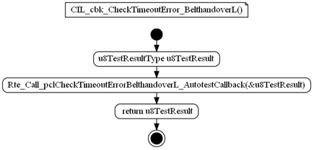

Figure :CIL_cbk_CheckTimeoutError_BelthandoverL

### CIL_cbk_CheckTimeoutError_BelthandoverR

|  |  |  |  |
| --- | --- | --- | --- |
| Object | | | |
| Callback of CIL_Autotest_CheckTimeoutError_BelthandoverR AutoTest. | | | |
| **Prototype** | | | |
| LOCAL u8TestResultType CIL_cbk_CheckTimeoutError_BelthandoverR (void) | | | |
| **Parameters** | | | |
| void | | | |
| **Remarks** | | | |
| None | | | |
| **Input parameters** | | | |
| Name | Type | Description | Range |
| NA | NA | NA | NA |
| **Output parameters** | | | |
| Name | Type | Description | Range |
| NA | NA | NA | NA |
| **Return value** | | | |
| Type | Description | | |
| u8TestResultType | u8TestResult | | |
| **Dynamic aspect** | | | |
| Who(callers) | Description | | |
| * | * | | |
| **Static aspect** | | | |
| * | | | |
| **Constrains** | | | |
|  | | | |

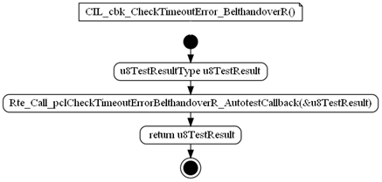

Figure :CIL_cbk_CheckTimeoutError_BelthandoverR

### CIL_cbk_CheckTimeoutError_Ignition

|  |  |  |  |
| --- | --- | --- | --- |
| Object | | | |
| Callback of CIL_Autotest_CheckTimeoutError_Ignition AutoTest. | | | |
| **Prototype** | | | |
| LOCAL u8TestResultType CIL_cbk_CheckTimeoutError_Ignition (void) | | | |
| **Parameters** | | | |
| void | | | |
| **Remarks** | | | |
| None | | | |
| **Input parameters** | | | |
| Name | Type | Description | Range |
| NA | NA | NA | NA |
| **Output parameters** | | | |
| Name | Type | Description | Range |
| NA | NA | NA | NA |
| **Return value** | | | |
| Type | Description | | |
| u8TestResultType | u8TestResult | | |
| **Dynamic aspect** | | | |
| Who(callers) | Description | | |
| * | * | | |
| **Static aspect** | | | |
| * | | | |
| **Constrains** | | | |
|  | | | |

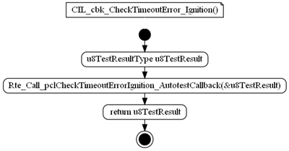

Figure :CIL_cbk_CheckTimeoutError_Ignition

### CIL_cbk_CheckTimeoutError_Powertrain

|  |  |  |  |
| --- | --- | --- | --- |
| Object | | | |
| Callback of CIL_Autotest_CheckTimeoutError_Powertrain AutoTest. | | | |
| **Prototype** | | | |
| LOCAL u8TestResultType CIL_cbk_CheckTimeoutError_Powertrain (void) | | | |
| **Parameters** | | | |
| void | | | |
| **Remarks** | | | |
| None | | | |
| **Input parameters** | | | |
| Name | Type | Description | Range |
| NA | NA | NA | NA |
| **Output parameters** | | | |
| Name | Type | Description | Range |
| NA | NA | NA | NA |
| **Return value** | | | |
| Type | Description | | |
| u8TestResultType | u8TestResult | | |
| **Dynamic aspect** | | | |
| Who(callers) | Description | | |
| * | * | | |
| **Static aspect** | | | |
| * | | | |
| **Constrains** | | | |
|  | | | |

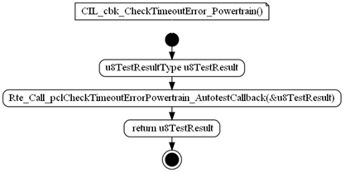

Figure :CIL_cbk_CheckTimeoutError_Powertrain

### EOL_cbk_CheckProductEndOfLifeMaxForce

|  |  |  |  |
| --- | --- | --- | --- |
| Object | | | |
| Callback of EOL_Autotest_CheckProductEndOfLifeMaxForce AutoTest. | | | |
| **Prototype** | | | |
| LOCAL u8TestResultType EOL_cbk_CheckProductEndOfLifeMaxForce (void) | | | |
| **Parameters** | | | |
| void | | | |
| **Remarks** | | | |
| None | | | |
| **Input parameters** | | | |
| Name | Type | Description | Range |
| NA | NA | NA | NA |
| **Output parameters** | | | |
| Name | Type | Description | Range |
| NA | NA | NA | NA |
| **Return value** | | | |
| Type | Description | | |
| u8TestResultType | u8TestResult | | |
| **Dynamic aspect** | | | |
| Who(callers) | Description | | |
| * | * | | |
| **Static aspect** | | | |
| * | | | |
| **Constrains** | | | |
|  | | | |

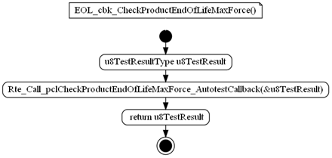

Figure : EOL_cbk_CheckProductEndOfLifeMaxForce

### PMP_cbk_CheckSystemUV

|  |  |  |  |
| --- | --- | --- | --- |
| Object | | | |
| Callback of PMP_Autotest_CheckSystemUV AutoTest. | | | |
| **Prototype** | | | |
| LOCAL u8TestResultType PMP_cbk_CheckSystemUV (void) | | | |
| **Parameters** | | | |
| void | | | |
| **Remarks** | | | |
| None | | | |
| **Input parameters** | | | |
| Name | Type | Description | Range |
| NA | NA | NA | NA |
| **Output parameters** | | | |
| Name | Type | Description | Range |
| NA | NA | NA | NA |
| **Return value** | | | |
| Type | Description | | |
| u8TestResultType | u8TestResult | | |
| **Dynamic aspect** | | | |
| Who(callers) | Description | | |
| * | * | | |
| **Static aspect** | | | |
| * | | | |
| **Constrains** | | | |
|  | | | |

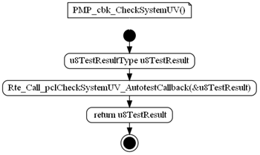

Figure :PMP_cbk_CheckSystemUV

### CIL_cbk_CheckSteeringConfiguration

|  |  |  |  |
| --- | --- | --- | --- |
| Object | | | |
| Callback of CIL_Autotest_CheckSteeringConfiguration AutoTest. | | | |
| **Prototype** | | | |
| LOCAL u8TestResultType CIL_cbk_CheckSteeringConfiguration (void) | | | |
| **Parameters** | | | |
| void | | | |
| **Remarks** | | | |
| None | | | |
| **Input parameters** | | | |
| Name | Type | Description | Range |
| NA | NA | NA | NA |
| **Output parameters** | | | |
| Name | Type | Description | Range |
| NA | NA | NA | NA |
| **Return value** | | | |
| Type | Description | | |
| u8TestResultType | u8TestResult | | |
| **Dynamic aspect** | | | |
| Who(callers) | Description | | |
| * | * | | |
| **Static aspect** | | | |
| * | | | |
| **Constrains** | | | |
|  | | | |

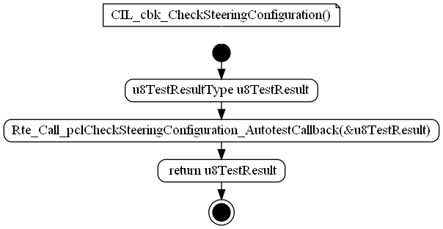

Figure : CIL_cbk_CheckSteeringConfiguration

### PMP_cbk_CheckSystemOV

|  |  |  |  |
| --- | --- | --- | --- |
| Object | | | |
| Callback of PMP_Autotest_CheckSystemOV AutoTest. | | | |
| **Prototype** | | | |
| LOCAL u8TestResultType PMP_cbk_CheckSystemOV (void) | | | |
| **Parameters** | | | |
| void | | | |
| **Remarks** | | | |
| None | | | |
| **Input parameters** | | | |
| Name | Type | Description | Range |
| NA | NA | NA | NA |
| **Output parameters** | | | |
| Name | Type | Description | Range |
| NA | NA | NA | NA |
| **Return value** | | | |
| Type | Description | | |
| u8TestResultType | u8TestResult | | |
| **Dynamic aspect** | | | |
| Who(callers) | Description | | |
| * | * | | |
| **Static aspect** | | | |
| * | | | |
| **Constrains** | | | |
|  | | | |

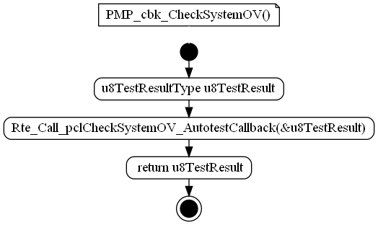

Figure :PMP_cbk_CheckSystemOV

### CIL_cbk_CheckImplausibleData_API

|  |  |  |  |
| --- | --- | --- | --- |
| Object | | | |
| Callback of CIL_Autotest_CheckImplausibleData_PowertrainRdy AutoTest. | | | |
| **Prototype** | | | |
| LOCAL u8TestResultType CIL_cbk_CheckImplausibleData_API (void) | | | |
| **Parameters** | | | |
| void | | | |
| **Remarks** | | | |
| None | | | |
| **Input parameters** | | | |
| Name | Type | Description | Range |
| NA | NA | NA | NA |
| **Output parameters** | | | |
| Name | Type | Description | Range |
| NA | NA | NA | NA |
| **Return value** | | | |
| Type | Description | | |
| u8TestResultType | u8TestResult | | |
| **Dynamic aspect** | | | |
| Who(callers) | Description | | |
| * | * | | |
| **Static aspect** | | | |
| * | | | |
| **Constrains** | | | |
|  | | | |

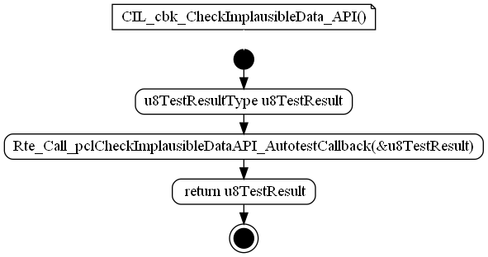

Figure CIL_cbk_CheckImplausibleData_API

### CIL_cbk_CheckImplausibleData_Powertrain_Rdy

|  |  |  |  |
| --- | --- | --- | --- |
| Object | | | |
| Callback of CIL_Autotest_CheckImplausibleData_PowertrainRdy AutoTest. | | | |
| **Prototype** | | | |
| LOCAL u8TestResultType CIL_cbk_CheckImplausibleData_Powertrain_Rdy (void) | | | |
| **Parameters** | | | |
| void | | | |
| **Remarks** | | | |
| None | | | |
| **Input parameters** | | | |
| Name | Type | Description | Range |
| NA | NA | NA | NA |
| **Output parameters** | | | |
| Name | Type | Description | Range |
| NA | NA | NA | NA |
| **Return value** | | | |
| Type | Description | | |
| u8TestResultType | u8TestResult | | |
| **Dynamic aspect** | | | |
| Who(callers) | Description | | |
| * | * | | |
| **Static aspect** | | | |
| * | | | |
| **Constrains** | | | |
|  | | | |

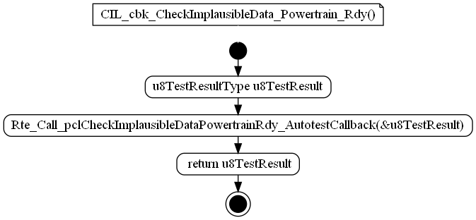

Figure CIL_cbk_CheckImplausibleData_Powertrain_Rdy

### CIL_cbk_CheckTimeoutError_Odospeedometer

|  |  |  |  |
| --- | --- | --- | --- |
| Object | | | |
| Callback of CIL_Autotest_CheckTimeoutError_OdoSpeedometer AutoTest. | | | |
| **Prototype** | | | |
| LOCAL u8TestResultType CIL_cbk_CheckTimeoutError_Odospeedometer (void) | | | |
| **Parameters** | | | |
| void | | | |
| **Remarks** | | | |
| None | | | |
| **Input parameters** | | | |
| Name | Type | Description | Range |
| NA | NA | NA | NA |
| **Output parameters** | | | |
| Name | Type | Description | Range |
| NA | NA | NA | NA |
| **Return value** | | | |
| Type | Description | | |
| u8TestResultType | u8TestResult | | |
| **Dynamic aspect** | | | |
| Who(callers) | Description | | |
| * | * | | |
| **Static aspect** | | | |
| * | | | |
| **Constrains** | | | |
|  | | | |

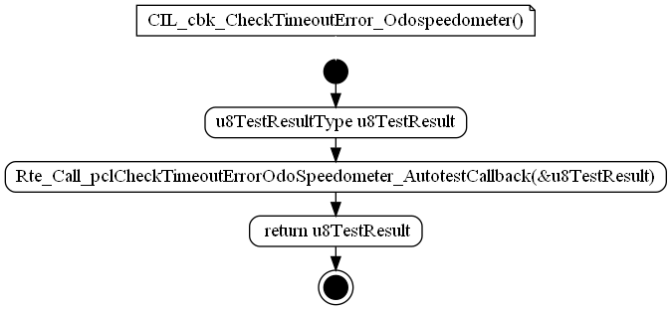

Figure CIL_cbk_CheckTimeoutError_Odospeedometer

### CIL_cbk_CheckVariantCoding

|  |  |  |  |
| --- | --- | --- | --- |
| Object | | | |
| Callback of CIL_Autotest_CheckVariantCoding AutoTest. | | | |
| **Prototype** | | | |
| LOCAL u8TestResultType CIL_cbk_CheckVariantCoding (void) | | | |
| **Parameters** | | | |
| void | | | |
| **Remarks** | | | |
| None | | | |
| **Input parameters** | | | |
| Name | Type | Description | Range |
| NA | NA | NA | NA |
| **Output parameters** | | | |
| Name | Type | Description | Range |
| NA | NA | NA | NA |
| **Return value** | | | |
| Type | Description | | |
| u8TestResultType | u8TestResult | | |
| **Dynamic aspect** | | | |
| Who(callers) | Description | | |
| * | * | | |
| **Static aspect** | | | |
| * | | | |
| **Constrains** | | | |
|  | | | |

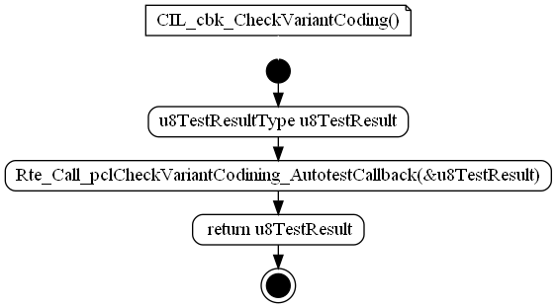

Figure CIL_cbk_CheckVariantCoding

### CIL_cbk_CheckTimeoutError_BeltAdj

|  |  |  |  |
| --- | --- | --- | --- |
| Object | | | |
| Callback of CIL_Autotest_CheckTimeoutError_BeltAdjAutoTest. | | | |
| **Prototype** | | | |
| LOCAL u8TestResultType CIL_cbk_CheckTimeoutError_BeltAdj (void) | | | |
| **Parameters** | | | |
| void | | | |
| **Remarks** | | | |
| None | | | |
| **Input parameters** | | | |
| Name | Type | Description | Range |
| NA | NA | NA | NA |
| **Output parameters** | | | |
| Name | Type | Description | Range |
| NA | NA | NA | NA |
| **Return value** | | | |
| Type | Description | | |
| u8TestResultType | u8TestResult | | |
| **Dynamic aspect** | | | |
| Who(callers) | Description | | |
| * | * | | |
| **Static aspect** | | | |
| * | | | |
| **Constrains** | | | |
|  | | | |

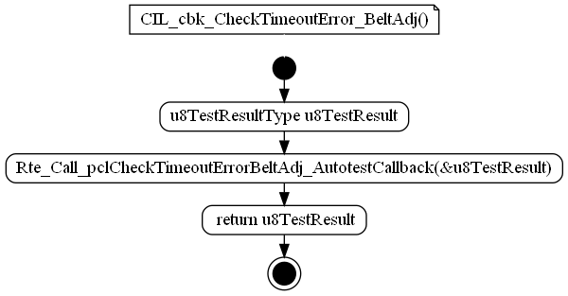

Figure CIL_cbk_CheckTimeoutError_BeltAdj

### SBC_cbk_SPIError

|  |  |  |  |
| --- | --- | --- | --- |
| Object | | | |
| Callback of SBC_ServiceAutotest_GetTestResult AutoTest. | | | |
| **Prototype** | | | |
| LOCAL u8TestResultType SBC_cbk_SPIError (void) | | | |
| **Parameters** | | | |
| void | | | |
| **Remarks** | | | |
| None | | | |
| **Input parameters** | | | |
| Name | Type | Description | Range |
| NA | NA | NA | NA |
| **Output parameters** | | | |
| Name | Type | Description | Range |
| NA | NA | NA | NA |
| **Return value** | | | |
| Type | Description | | |
| u8TestResultType | u8TestResult | | |
| **Dynamic aspect** | | | |
| Who(callers) | Description | | |
| * | * | | |
| **Static aspect** | | | |
| * | | | |
| **Constrains** | | | |
|  | | | |

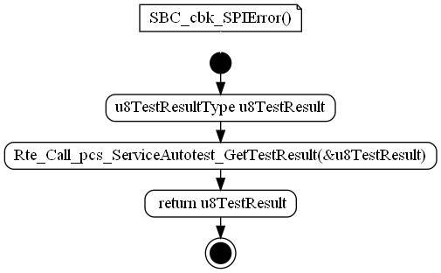

Figure SBC_cbk_SPIError

## Types

### stAutoTestConfigurationType

|  |  |  |
| --- | --- | --- |
| **Field Name** | **Field Type** | **Field description** |
| u8TestResultType (*pfAutotestCallback)(void) | u8TestResultType (*pfAutotestCallback)(void) | Function pointer used to store the auto-test callback |
| u8AecIdentifier | u8AecIdentifierType | ERH AEC identifier |
| u8InhibIndex | u32ModeMaskType | Index in cau32InhibitingModes array, to select a combination of inhibition modes to be checked before executing a test. |

### stCyclicListEltType

|  |  |  |
| --- | --- | --- |
| **Field Name** | **Field Type** | **Field description** |
| u16Period | uint16 | Test period in number of ATM execution occurrences |
| u8Offset | uint8 | Offset (in number of ATM execution occurrences) |
| u8TestIndex | uint8 | Auto-test index in the configuration |

### stStartupEltType

|  |  |  |
| --- | --- | --- |
| **Field Name** | **Field Type** | **Field description** |
| u16StepPeriod | uint16 | Test period in number of ATM execution occurrences |
| u8Type | uint8 | Auto-test type (one shot / one shot abort / one shot retry) |
| u8TestIndex | uint8 | Auto-test index in the configuration |

## Variables

### atm_au8AtStatuses[ATM_KU8_NB_OF_AUTOTEST]

|  |  |  |
| --- | --- | --- |
| Type | Value |  |
| uint8 | NA | |
| **Description** | | |
| This variable contains the status of each test (RAM). | | |
| **Definition** | | |
| LOCAL uint8 au8AtStatuses[ATM_KU8_NB_OF_AUTOTEST] | | |

### atm_u16CurrentDecade

|  |  |  |
| --- | --- | --- |
| Type | Value |  |
| uint16 | NA | |
| **Description** | | |
| This variable represents the cycle decade counter. Initialized by ATM_Init. | | |
| **Definition** | | |
| LOCAL uint16 u16CurrentDecade | | |
| **Range** | | |
| 0..59000 | | |

### atm_u16StartupPeriodCnt

|  |  |  |
| --- | --- | --- |
| Type | Value |  |
| uint16 | NA | |
| **Description** | | |
| This variable is used only during the start-up sequence to count the period between execution step of tests (if executed during several steps). Initialized by ATM_Init. | | |
| **Definition** | | |
| LOCAL uint16 u16StartupPeriodCnt | | |

### atm_u8CurrentTask

|  |  |  |
| --- | --- | --- |
| Type | Value |  |
| uint8 | NA | |
| **Description** | | |
| This variable represents the cyclic task counter. Initialized by ATM_Init. | | |
| **Definition** | | |
| LOCAL uint8 u8CurrentTask | | |
| **Range** | | |
| 0..4 | | |

### atm_u8CyclicTestIndex

|  |  |  |
| --- | --- | --- |
| Type | Value |  |
| uint8 | NA | |
| **Description** | | |
| Loop indexes the 'castCyclicList' array over several execution of the main function, only after the completion of the start-up test sequence. Range : [0..255] Initialized by ATM_Init. | | |
| **Definition** | | |
| LOCAL uint8 u8CyclicTestIndex | | |
| **Range** | | |
| 0..255 | | |

### atm_u8StartupTestIndex

|  |  |  |
| --- | --- | --- |
| Type | Value |  |
| uint8 | NA | |
| **Description** | | |
| Indexes the 'castStartupList' array during the start-up test sequence over several execution of the main function. This array is browsed once, after what main function will follow the cyclic list of test. Initialized by ATM_Init. | | |
| **Definition** | | |
| LOCAL uint8 u8StartupTestIndex | | |
| **Range** | | |
| 0..255 | | |

### castATMConfig[ATM_KU8_NB_OF_AUTOTEST]

|  |  |  |
| --- | --- | --- |
| Type | Value |  |
| const stAutoTestConfigurationType | 52 | |
| **Description** | | |
| Common test properties. | | |
| **Definition** | | |
| EXPORTED const stAutoTestConfigurationType castATMConfig[ATM_KU8_NB_OF_AUTOTEST] | | |

### castRunningCyclicList[((uint8) 50)]

|  |  |  |
| --- | --- | --- |
| Type | Value |  |
| const stCyclicListEltType | 49 | |
| **Description** | | |
| This table of cyclic tests is run after the last "one shot" test. | | |
| **Definition** | | |
| EXPORTED const stCyclicListEltType castRunningCyclicList[((uint8) 52)] | | |

### castStartupCyclicList[((uint8) 6)]

|  |  |  |
| --- | --- | --- |
| Type | Value |  |
| const stCyclicListEltType | 4 | |
| **Description** | | |
| This table of cyclic tests is run in parallel with the "one shot" tests list. | | |
| **Definition** | | |
| EXPORTED const stCyclicListEltType castStartupCyclicList[((uint8) 11)] | | |

### castStartupSequentialList[((uint8) 17)]

|  |  |  |
| --- | --- | --- |
| Type | Value |  |
| const stStartupEltType | 17 | |
| **Description** | | |
| This table of "one shot" tests is run once at startup. Each test is run only after the previous one completion. | | |
| **Definition** | | |
| EXPORTED const stStartupEltType castStartupSequentialList[((uint8) 17)] | | |

### cau32InhibitingModes[((uint8) 4)]

|  |  |  |
| --- | --- | --- |
| Type | Value |  |
| const u32ModeMaskType | 4 | |
| **Description** | | |
| This array is a list of possible inhibition modes combinations that can be checked before test executions.Goal: As several tests execution share the same combination, theses combinations (32 bits bitfield) are stored in this array, and tests attributes can be only a 8 bits index to save flash memory. | | |
| **Definition** | | |
| EXPORTED const u32ModeMaskType cau32InhibitingModes[((uint8) 4)] | | |

## Constants

### ATM_AC_AutoTestManager_START_SEC_CODE

|  |  |
| --- | --- |
| Name | Value |
| ATM_AC_AutoTestManager_START_SEC_CODE | NA |
| **Definition** | |
| #define ATM_AC_AutoTestManager_START_SEC_CODE | |
| **Description** | |
| NA | |

### ATM_AC_AutoTestManager_START_SEC_VAR_16

|  |  |
| --- | --- |
| Name | Value |
| ATM_AC_AutoTestManager_START_SEC_VAR_16 | NA |
| **Definition** | |
| #define ATM_AC_AutoTestManager_START_SEC_VAR_16 | |
| **Description** | |
| NA | |

### ATM_AC_AutoTestManager_START_SEC_VAR_8

|  |  |
| --- | --- |
| Name | Value |
| ATM_AC_AutoTestManager_START_SEC_VAR_8 | NA |
| **Definition** | |
| #define ATM_AC_AutoTestManager_START_SEC_VAR_8 | |
| **Description** | |
| NA | |

### ATM_AC_AutoTestManager_STOP_SEC_CODE

|  |  |
| --- | --- |
| Name | Value |
| ATM_AC_AutoTestManager_STOP_SEC_CODE | NA |
| **Definition** | |
| #define ATM_AC_AutoTestManager_STOP_SEC_CODE | |
| **Description** | |
| NA | |

### ATM_AC_AutoTestManager_STOP_SEC_VAR_16

|  |  |
| --- | --- |
| Name | Value |
| ATM_AC_AutoTestManager_STOP_SEC_VAR_16 | NA |
| **Definition** | |
| #define ATM_AC_AutoTestManager_STOP_SEC_VAR_16 | |
| **Description** | |
| NA | |

### ATM_AC_AutoTestManager_STOP_SEC_VAR_8

|  |  |
| --- | --- |
| Name | Value |
| ATM_AC_AutoTestManager_STOP_SEC_VAR_8 | NA |
| **Definition** | |
| #define ATM_AC_AutoTestManager_STOP_SEC_VAR_8 | |
| **Description** | |
| NA | |

### U16_GET_STEP_PERIOD(index)

|  |  |
| --- | --- |
| Name | Value |
| U16_GET_STEP_PERIOD(index) | (index) (castStartupSequentialList[(index)].u16StepPeriod) |
| **Definition** | |
| #define U16_GET_STEP_PERIOD(index) (castStartupSequentialList[(index)].u16StepPeriod) | |
| **Description** | |
| Define for reinitialize the step period index. | |

### U8_GET_AEC_ID(index)

|  |  |
| --- | --- |
| Name | Value |
| U8_GET_AEC_ID(index) | (index) (castATMConfig[index]. u8AecIdentifier) |
| **Definition** | |
| U8_GET_AEC_ID(index) (castATMConfig[index].u8AecIdentifier) | |
| **Description** | |
| Define for autotest ID | |

### ATM_AC_AutoTestManager_START_SEC_CONST_UNSPECIFIED

|  |  |
| --- | --- |
| Name | Value |
| ATM_AC_AutoTestManager_START_SEC_CONST_UNSPECIFIED | NA |
| **Definition** | |
| #define ATM_AC_AutoTestManager_START_SEC_CONST_UNSPECIFIED | |
| **Description** | |
| NA | |

### ATM_AC_AutoTestManager_STOP_SEC_CONST_UNSPECIFIED

|  |  |
| --- | --- |
| Name | Value |
| ATM_AC_AutoTestManager_STOP_SEC_CONST_UNSPECIFIED | NA |
| **Definition** | |
| #define ATM_AC_AutoTestManager_STOP_SEC_CONST_UNSPECIFIED | |
| **Description** | |
| NA | |

### IN_DECADE_0

|  |  |
| --- | --- |
| Name | Value |
| IN_DECADE_0 | ((uint8)0) |
| **Definition** | |
| #define IN_DECADE_0 ((uint8)0) | |
| **Description** | |
| Decade used for macros - example: KU8_ATM_PERIODIC_100_MS(decade) | |

### IN_DECADE_1

|  |  |
| --- | --- |
| Name | Value |
| IN_DECADE_1 | ((uint8)1) |
| **Definition** | |
| #define IN_DECADE_1 ((uint8)1) | |
| **Description** | |
| Decade used for macros - example: KU8_ATM_PERIODIC_100_MS(decade) | |

### IN_DECADE_2

|  |  |
| --- | --- |
| Name | Value |
| IN_DECADE_2 | ((uint8)2) |
| **Definition** | |
| #define IN_DECADE_2 ((uint8)2) | |
| **Description** | |
| Decade used for macros - example: KU8_ATM_PERIODIC_100_MS(decade) | |

### IN_DECADE_3

|  |  |
| --- | --- |
| Name | Value |
| IN_DECADE_3 | ((uint8)3) |
| **Definition** | |
| #define IN_DECADE_3 ((uint8)3) | |
| **Description** | |
| Decade used for macros - example: KU8_ATM_PERIODIC_100_MS(decade) | |

### IN_DECADE_4

|  |  |
| --- | --- |
| Name | Value |
| IN_DECADE_4 | ((uint8)4) |
| **Definition** | |
| #define IN_DECADE_4 ((uint8)4) | |
| **Description** | |
| Decade used for macros - example: KU8_ATM_PERIODIC_100_MS(decade) | |

### IN_DECADE_5

|  |  |
| --- | --- |
| Name | Value |
| IN_DECADE_5 | ((uint8)5) |
| **Definition** | |
| #define IN_DECADE_5 ((uint8)5) | |
| **Description** | |
| Decade used for macros - example: KU8_ATM_PERIODIC_100_MS(decade) | |

### IN_DECADE_6

|  |  |
| --- | --- |
| Name | Value |
| IN_DECADE_6 | ((uint8)6) |
| **Definition** | |
| #define IN_DECADE_6 ((uint8)6) | |
| **Description** | |
| Decade used for macros - example: KU8_ATM_PERIODIC_100_MS(decade) | |

### IN_DECADE_7

|  |  |
| --- | --- |
| Name | Value |
| IN_DECADE_7 | ((uint8)7) |
| **Definition** | |
| #define IN_DECADE_7 ((uint8)7) | |
| **Description** | |
| Decade used for macros - example: KU8_ATM_PERIODIC_100_MS(decade) | |

### IN_DECADE_8

|  |  |
| --- | --- |
| Name | Value |
| IN_DECADE_8 | ((uint8)8) |
| **Definition** | |
| #define IN_DECADE_8 ((uint8)8) | |
| **Description** | |
| Decade used for macros - example: KU8_ATM_PERIODIC_100_MS(decade) | |

### IN_DECADE_9

|  |  |
| --- | --- |
| Name | Value |
| IN_DECADE_9 | ((uint8)9) |
| **Definition** | |
| #define IN_DECADE_9 ((uint8)9) | |
| **Description** | |
| Decade used for macros - example: KU8_ATM_PERIODIC_100_MS(decade) | |

### KU16_STEP_EVERY_10MS

|  |  |
| --- | --- |
| Name | Value |
| KU16_STEP_EVERY_10MS | ((uint16)1) |
| **Definition** | |
| #define KU16_STEP_EVERY_10MS ((uint16)1) | |
| **Description** | |
| Decade argument value for macro. | |

### KU16_STEP_EVERY_1S

|  |  |
| --- | --- |
| Name | Value |
| KU16_STEP_EVERY_1S | ((uint16)100) |
| **Definition** | |
| #define KU16_STEP_EVERY_10S ((uint16)100) | |
| **Description** | |
| Decade argument value for macro. | |

### KU16_STEP_EVERY_200MS

|  |  |
| --- | --- |
| Name | Value |
| KU16_STEP_EVERY_200MS | ((uint16)20) |
| **Definition** | |
| #define KU16_STEP_EVERY_200MS ((uint16)20) | |
| **Description** | |
| Decade argument value for macro. | |

### KU16_STEP_EVERY_500MS

|  |  |
| --- | --- |
| Name | Value |
| KU16_STEP_EVERY_500MS | ((uint16)50) |
| **Definition** | |
| #define KU16_STEP_EVERY_500MS ((uint16)50) | |
| **Description** | |
| Decade argument value for macro. | |

### KU16_STEP_EVERY_100MS

|  |  |
| --- | --- |
| Name | Value |
| KU16_STEP_EVERY_100MS | ((uint16)10) |
| **Definition** | |
| #define KU16_STEP_EVERY_100MS ((uint16)10) | |
| **Description** | |
| Decade argument value for macro. | |

### KU8_ATM_ONE_SHOT(step_period)

|  |  |
| --- | --- |
| Name | Value |
| KU8_ATM_ONE_SHOT(step_period) | (step_period) (step_period), KU8_AUTO_TEST_CONFIG_TYPE_ONE_SHOT |
| **Definition** | |
| #define KU8_ATM_ONE_SHOT(step_period) (step_period), KU8_AUTO_TEST_CONFIG_TYPE_ONE_SHOT | |
| **Description** | |
| The autotest is called only once and it is considered as finished whatever its result is : OK, NOK, NotDecided. | |

### KU8_ATM_ONE_SHOT_ABORT(step_period)

|  |  |
| --- | --- |
| Name | Value |
| KU8_ATM_ONE_SHOT_ABORT(step_period) | (step_period) (step_period), KU8_AUTO_TEST_CONFIG_TYPE_ONE_SHOT_ABORT |
| **Definition** | |
| #define KU8_ATM_ONE_SHOT_ABORT(step_period) (step_period), KU8_AUTO_TEST_CONFIG_TYPE_ONE_SHOT_ABORT | |
| **Description** | |
| The autotest is periodically called until its result is OK or NOK. It is considered as finished only when its result is OK or NOK. | |

### KU8_ATM_ONE_SHOT_DECIDED(step_period)

|  |  |
| --- | --- |
| Name | Value |
| KU8_ATM_ONE_SHOT_DECIDED(step_period) | (step_period) (step_period), KU8_AUTO_TEST_CONFIG_TYPE_ONE_SHOT_DECIDED |
| **Definition** | |
| #define KU8_ATM_ONE_SHOT_DECIDED(step_period) (step_period), KU8_AUTO_TEST_CONFIG_TYPE_ONE_SHOT_DECIDED | |
| **Description** | |
| The autotest is periodically called until its result is OK, NOK or NOT DECIDED. It is considered as finished only when its result is OK, NOK or NOT DECIDED. | |

### KU8_ATM_ONE_SHOT_RETRY(step_period)

|  |  |
| --- | --- |
| Name | Value |
| KU8_ATM_ONE_SHOT_RETRY(step_period) | (step_period) (step_period), KU8_AUTO_TEST_CONFIG_TYPE_ONE_SHOT_RETRY |
| **Definition** | |
| #define KU8_ATM_ONE_SHOT_RETRY(step_period) (step_period), KU8_AUTO_TEST_CONFIG_TYPE_ONE_SHOT_RETRY | |
| **Description** | |
| The autotest is periodically called until its result is OK. It is considered as finished only when its result is OK. | |

### KU8_ATM_PERIODIC_100_MS(decade)

|  |  |
| --- | --- |
| Name | Value |
| KU8_ATM_PERIODIC_100_MS(decade) | (decade) (uint16)10u, (decade) |
| **Definition** | |
| #define KU8_ATM_PERIODIC_100_MS(decade) (uint16)10u, (decade) | |
| **Description** | |
| Main timing (100 ms) Auto tests manager parameters macros, to be used in 'castATMConfig' definition. | |

### KU8_ATM_PERIODIC_10_MS

|  |  |
| --- | --- |
| Name | Value |
| KU8_ATM_PERIODIC_10_MS | (uint16)1u, (uint8)0u |
| **Definition** | |
| #define KU8_ATM_PERIODIC_10_MS (uint16)1u, (uint8)0u | |
| **Description** | |
| Main timing (10 ms) Auto tests manager parameters macros, to be used in 'castATMConfig' definition. | |

### KU8_ATM_PERIODIC_20_MS

|  |  |
| --- | --- |
| Name | Value |
| KU8_ATM_PERIODIC_20_MS | (uint16)1u, (uint8)0u |
| **Definition** | |
| #define KU8_ATM_PERIODIC_20_MS (uint16)1u, (uint8)0u | |
| **Description** | |
| Main timing (20 ms) Auto tests manager parameters macros, to be used in 'castATMConfig' definition. | |

### KU8_ATM_PERIODIC_1_S(decade)

|  |  |
| --- | --- |
| Name | Value |
| KU8_ATM_PERIODIC_1_S(decade) | (decade) (uint16)100u, (decade) |
| **Definition** | |
| #define KU8_ATM_PERIODIC_1_S(decade) (uint16)100u, (decade) | |
| **Description** | |
| Main timing (1 s) Auto tests manager parameters macros, to be used in 'castATMConfig' definition. | |

### KU8_END_OF_SUB_LIST

|  |  |
| --- | --- |
| Name | Value |
| KU8_END_OF_SUB_LIST | (uint16)0, (uint8)1, (uint8)0 |
| **Definition** | |
| #define KU8_END_OF_SUB_LIST (uint16)0, (uint8)1, (uint8)0 | |
| **Description** | |
| Delimiter used between lists. Indicates to the ATM main function to continue with its current indexes. | |

### KU8_END_OF_THE_WHOLE_LIST

|  |  |
| --- | --- |
| Name | Value |
| KU8_END_OF_THE_WHOLE_LIST | (uint16)0, (uint8)0, (uint8)0 |
| **Definition** | |
| #define KU8_END_OF_THE_WHOLE_LIST (uint16)0, (uint8)0, (uint8)0 | |
| **Description** | |
| Delimiter used to terminate the list. Indicates to the ATM main function to loop back to the first list and reset all its indexes. | |

### KU16_CFG_MAX_DECADE

|  |  |
| --- | --- |
| Name | Value |
| KU16_CFG_MAX_DECADE | ((uint16)60000) |
| **Definition** | |
| #define KU16_CFG_MAX_DECADE ((uint16)60000) | |
| **Description** | |
| NA | |

### KU16_CFG_MAX_TASK

|  |  |
| --- | --- |
| Name | Value |
| KU16_CFG_MAX_TASK | ((uint16)5) |
| **Definition** | |
| #define KU16_CFG_MAX_TASK ((uint16)5) | |
| **Description** | |
| NA | |

### KU8_MODES______________________INHIB

|  |  |
| --- | --- |
| Name | Value |
| KU8_MODES______________________INHIB | ((uint8)0) |
| **Definition** | |
| #define KU8_MODES______________________INHIB ((uint8)0) | |
| **Description** | |
| NA | |

### KU8_MODES________VOLTAG_INHIB

|  |  |
| --- | --- |
| Name | Value |
| KU8_MODES________VOLTAG_INHIB | ((uint8)1) |
| **Definition** | |
| #define KU8_MODES________VOLTAG_INHIB ((uint8)1) | |
| **Description** | |
| NA | |

### KU8_MODES_BELTFN________INHIB

|  |  |
| --- | --- |
| Name | Value |
| KU8_MODES_BELTFN________INHIB | ((uint8)3) |
| **Definition** | |
| #define KU8_MODES_BELTFN________INHIB ((uint8)3) | |
| **Description** | |
| NA | |

### KU8_MODES_BELTFN_VOLTAG_INHIB

|  |  |
| --- | --- |
| Name | Value |
| KU8_MODES_BELTFN_VOLTAG_INHIB | ((uint8)2) |
| **Definition** | |
| #define KU8_MODES_BELTFN_VOLTAG_INHIB ((uint8)2) | |
| **Description** | |
| NA | |

### KU8_NUMBER_OF_INHIBITING_MODES

|  |  |
| --- | --- |
| Name | Value |
| KU8_NUMBER_OF_INHIBITING_MODES | ((uint8)5) |
| **Definition** | |
| #define KU8_NUMBER_OF_INHIBITING_MODES ((uint8)5) | |
| **Description** | |
| NA | |

### ATM_KU8_NB_OF_STARTUP_AUTO_TESTS

|  |  |
| --- | --- |
| Name | Value |
| ATM_KU8_NB_OF_STARTUP_AUTO_TESTS | ((uint8) 17) |
| **Definition** | |
| #define ATM_KU8_NB_OF_STARTUP_AUTO_TESTS ((uint8) 17) | |
| **Description** | |
| NA | |

### KU8_NB_OF_RUNNING_CYCLIC_ELTS

|  |  |
| --- | --- |
| Name | Value |
| KU8_NB_OF_RUNNING_CYCLIC_ELTS | ((uint8)45) |
| **Definition** | |
| #define KU8_NB_OF_RUNNING_CYCLIC_ELTS ((uint8)45) | |
| **Description** | |
| NA | |

### KU8_NB_OF_STARTUP_CYCLIC_ELTS

|  |  |
| --- | --- |
| Name | Value |
| KU8_NB_OF_STARTUP_CYCLIC_ELTS | ((uint8)6) |
| **Definition** | |
| #define KU8_NB_OF_STARTUP_CYCLIC_ELTS ((uint8)6) | |
| **Description** | |
| NA | |

### KU8_AUTO_TEST_CONFIG_NO_TYPE

|  |  |
| --- | --- |
| Name | Value |
| KU8_AUTO_TEST_CONFIG_NO_TYPE | ((uint8)(0x00)) |
| **Definition** | |
| #define KU8_AUTO_TEST_CONFIG_NO_TYPE ((uint8)(0x00)) | |
| **Description** | |
| NA | |

### KU8_AUTO_TEST_CONFIG_TYPE_ONE_SHOT

|  |  |
| --- | --- |
| Name | Value |
| KU8_AUTO_TEST_CONFIG_TYPE_ONE_SHOT | ((uint8)(0x08)) /* execution until OK or NOK */ |
| **Definition** | |
| #define KU8_AUTO_TEST_CONFIG_TYPE_ONE_SHOT ((uint8)(0x08)) /* execution until OK or NOK */ | |
| **Description** | |
| NA | |

### KU8_AUTO_TEST_CONFIG_TYPE_ONE_SHOT_ABORT

|  |  |
| --- | --- |
| Name | Value |
| KU8_AUTO_TEST_CONFIG_TYPE_ONE_SHOT_ABORT | ((uint8)(0x02)) /* execution frozen if NOK */ |
| **Definition** | |
| #define KU8_AUTO_TEST_CONFIG_TYPE_ONE_SHOT_ABORT ((uint8)(0x02)) /* execution frozen if NOK */ | |
| **Description** | |
| NA | |

### KU8_AUTO_TEST_CONFIG_TYPE_ONE_SHOT_DECIDED

|  |  |
| --- | --- |
| Name | Value |
| KU8_AUTO_TEST_CONFIG_TYPE_ONE_SHOT_DECIDED | ((uint8)(0x10)) /* Retry until different from NOT DECIDED */ |
| **Definition** | |
| #define KU8_AUTO_TEST_CONFIG_TYPE_ONE_SHOT_DECIDED ((uint8)(0x10)) /* Retry until different from NOT DECIDED */ | |
| **Description** | |
| NA | |

### KU8_AUTO_TEST_CONFIG_TYPE_ONE_SHOT_RETRY

|  |  |
| --- | --- |
| Name | Value |
| KU8_AUTO_TEST_CONFIG_TYPE_ONE_SHOT_RETRY | ((uint8)(0x04)) /* execution until OK */ |
| **Definition** | |
| #define KU8_AUTO_TEST_CONFIG_TYPE_ONE_SHOT_RETRY ((uint8)(0x04)) /* execution until OK */ | |
| **Description** | |
| NA | |

### KU8_AUTO_TEST_CONFIG_TYPE_PERIODIC

|  |  |
| --- | --- |
| Name | Value |
| KU8_AUTO_TEST_CONFIG_TYPE_PERIODIC | ((uint8)(0x01)) |
| **Definition** | |
| #define KU8_AUTO_TEST_CONFIG_TYPE_PERIODIC ((uint8)(0x01)) | |
| **Description** | |
| NA | |

# EEPROM

The EEPROM parameters are all specified in [Doc3 = SBE_4G_NVP_layout.xls].

Refer to this document for more details.

# Configuration

No special configuration for ATM software component.

# Compilation Options

No compilation options for ATM software component.